# **Simulation model**

This chapter provides a comprehensive explanation of simulation models for two situations. The first scenario involves a single node. The second scenario is a network composed of three interconnected nodes. The above are both batch arrivals, and each may consist of one or two packets arriving at a time. To create and simulate these models, we code in C Programming Language.

## Scenario 1

Under this scenario's conditions, we consider a single sensor node with two priorities. Both priorities packets have the same energy requirements. The packets in this scenario are in batch arrival, which arrive with one or two packets at a time. The energy required for operation can be supplied by either harvested energy or a regular battery. For clarity, we have divided the simulation into one main program and seven subprograms.

### Main program

The program depicted in Fig. 4 - 1 follows several steps to simulate the system. First, all variables used in the simulation are initialized, including setting the statistics parameters to zero, the server state to idle, the next departure time to infinite. Next, the user is prompted to input various parameters via the keyboard, such as the packet queue capacity $(N)$, energy queue capacity $(K)$, mean arrival rate of energy units $(β)$, mean batch arrival rates of one packet with HP and LP $\left(λ_{H},λ_{L}\right)$, mean batch arrival rates of two packets with HP and LP $\left(λ_{H2},λ_{L2}\right)$, mean service rates $(μ_{H},μ_{L})$, mean impatient rates of HP and LP packets $(α_{H},α_{L})$, the probability of HP and LP packets using regular battery $(θ_{H},θ_{L})$, and the number of packets required. The program then generates the next energy arrival time and batch packet arrival times using an exponential variate function based on the input values. In the second step, the program compares the times of the seven possible events and selects the earliest one to execute the corresponding subprogram. Finally, a "while loop" is used to repeat the second step until the required number of packets are served, at which point the simulation ends and the performance results are displayed.

### HP packet arrival subprogram

Fig. 4 - 2 illustrates the flow chart of the subprogram for HP packet arrival with one packet per batch. Initially, the program updates the current simulation time as the HP packet arrival time and generates the next HP packet arrival time using the exponential variate function with the arrival rate $λ_{H}$. The program then accumulates the total number of arrived packets, packets in the queue, and packets in the system separately. It checks whether the packet queue is full or not. If the packet queue is not full, the program adds one packet to the queue and inserts the related information of the HP packet at the front of all LP packets. It generates the impatient time using the exponential variate function with $α_{H}$. On the other hand, if the queue is full, the program increases the number of blocked packets by one. The program then describes the situations divided into the following cases.

1. The first step is to check the status of the server. If it is not "IDLE", we update the next impatient time by considering the impatient time of packets waiting in the queue. However, if the server is "IDLE", we need to check whether the energy units in the energy queue are sufficient to meet the energy requirement of the packet at the front of the packet queue.
2. The second step involves checking whether there are enough energy units in the energy queue to serve the packet at the head of the packet queue. If there are enough units, the relevant statuses are updated, including the energy and packet queue sizes, server status, and waiting and service times. The departure time is then generated using an exponential variate function, and the packets in the queue are shifted one position. The next impatient time is updated or set to "infinite" based on the status of the packet queue.
3. If the number of energy units in the energy queue is insufficient to serve the packet, a random value between 0 and 1 is generated, which is compared with the probability of regular battery usage $θ_{H}/θ_{L}$. If it is less than or equal to $θ_{H}/θ_{L}$, we update the relevant statuses and accumulate the appropriate time, including the number of energy units consumed from the regular battery, which are not in the energy queue. Next, the departure time is generated using the exponential variate function with $μ_{H}/μ_{L}$, and all the remaining packets in the packet queue are moved forward one place. Finally, depending on whether the packet queue is empty or not, we decide whether to update the next impatient time or set it to infinite.
4. If the number of energy units in the energy queue is insufficient and the random value is greater than $θ_{H}/θ_{L}$, then the next impatient time needs to be updated based on the impatient time of packets in the queue.

### LP packet arrival subprogram

Fig. 4 - 3 illustrates the flow chart of the subprogram for LP packet arrival with one packet per batch. To begin, the current simulation time is updated as the LP packet arrival time and the next LP packet arrival time is generated using the exponential variate function with $λ_{L}$. Additionally, the total number of arrived packets, packets in the queue, and packets in the system are accumulated separately. The program checks whether the packet queue is full, and if not, it adds one packet to the queue and stores the related information of the LP packet at the end of the queue. The impatient time is generated using the exponential variate function with $α_{L}$. If the queue is full, the number of blocked packets is increased by one. The program then describes the cases that follow.

1. The first step is to check the server's status. If it is not "IDLE", we update the next impatient time based on the impatient time of packets in the queue. If the server is "IDLE", the next step is to determine whether the number of energy units in the energy queue is sufficient to meet the energy requirement of the packet at the head of the packet queue.
2. The next step involves checking if there are enough energy units in the energy queue to serve the packet at the head of the packet queue. If the energy is sufficient, the program will update various statuses and accumulate relevant time according to the priority of the packet. These include the number of energy units in the energy queue, the number of packets in the packet queue, the server status, the total waiting time in the queue, and the total service time. Subsequently, the departure time is generated by using the exponential variate function with $μ_{H}/μ_{L}$. Then, all the remaining packets in the packet queue are shifted forward by one position. Finally, it is decided whether the next impatient time should be updated or set to infinite, depending on whether the packet queue is empty or not.
3. The third step involves checking if the number of energy units in the energy queue is insufficient to serve the packet at the head of the packet queue. In such a case, a random value between 0 and 1 is generated and compared with the regular battery usage probability $θ_{H}/θ_{L}$. If this value is less than or equal to $θ_{H}/θ_{L}$, we proceed to update various statuses and accumulate relevant time, including the consumption of energy units from the regular battery, excluding those in the energy queue. Following this, the departure time is generated using the exponential variate function with $μ_{H}/μ_{L}$. After that, all remaining packets in the packet queue move forward one place. Lastly, we decide whether the next impatient time needs to be updated or set to infinite, based on the state of the packet queue.
4. In the fourth situation, when the number of energy units in the energy queue is insufficient and the random value is greater than $θ_{H}/θ_{L}$, we only need to update the next impatient time based on the impatient time of packets in the queue. No other status or time accumulation is necessary. Fourth, the number of energy units in the energy queue is insufficient, and the random value is greater than $θ_{H}/θ_{L}$, then we just need to update the next impatient time based on the impatient time of packets in the queue.

### Energy arrival subprogram

The flow chart graphic of the energy arrival subprogram is shown in Fig. 4 - 4. In the beginning, the current simulation time is updated as the energy arrival time, and then we generate the next energy arrival time by the exponential variate function with . Besides, the total number of arrived energy units is accumulated. Next, we determine whether the energy queue is full. If not, we increase the number of energy units in the energy queue by one. Conversely, if the energy queue is full, the number of blocked energy units is increased by one. Afterwards, the situation can be divided into the following cases for description.

1. First, we check sequentially if the server status is "IDLE" and if there are any packets in the packet queue. If both of the above conditions are met, then it is necessary to determine whether the number of energy units in the energy queue is greater than or equal to the energy requirement of the packet at the head of the packet queue. Otherwise, the subprogram will simply return to the main program without executing anything.
2. Second, if the number of energy units in the energy queue is enough to serve the packet, we update various statuses and accumulate the relevant time according to the priority of the packet, such as, the number of energy units in the energy queue, the number of packets in the packet queue, the server status, the total waiting time in the queue and the total service time. After that, the departure time will be generated by the exponential variate function with . Then, all remaining packets in the packet queue move forward one place. Finally, we decide whether the next impatient time should be updated or set to be infinite, depending on if the packet queue is empty.
3. Third, if the number of energy units in the energy queue is insufficient, a random value between 0 and 1 is generated and compared with the regular battery usage probability . If it is less than or equal to , we update various statuses and accumulate the relevant time. This includes the number of energy units consumed from the regular battery, but not those in the energy queue. After that, the departure time will be generated by the exponential variate function with . Then, all remaining packets in the packet queue move forward one place. Finally, we decide whether the next impatient time should be updated or set to be infinite, depending on if the packet queue is empty.
4. Fourth, the number of energy units in the energy queue is insufficient, and the random value is greater than the , then the subprogram will simply return to the main program without executing anything.

### Impatient subprogram

The flow chart graphic of the impatient subprogram is shown in Fig. 4 - 5. In the beginning, the current simulation time is updated as the next impatient time, and then we identify the $i$ th packet that should be removed from the packet queue due to impatience. In addition, the total number of impatient packets and total impatient time are accumulated based on the priority of the packet. Next, we reduce the number of packets in the queue by one and move all packets after the th position forward one place to overwrite the packet's original information. Afterwards, the situation can be divided into the following cases for description.

1. First, we check if the packet queue is empty. If so, the next impatient time is set to be infinite. Otherwise, we take one step further and check whether the server status is "IDLE" or not.
2. Second, if the server is busy, we update the next impatient time based on the impatient time of packets in the queue. On the contrary, it is necessary to determine whether the number of energy units in the energy queue is greater than or equal to the energy requirement of the packet at the head of the packet queue.
3. Third, if the number of energy units in the energy queue is enough to serve the packet, we update various statuses and accumulate the relevant time according to the priority of the packet, such as, the number of energy units in the energy queue, the number of packets in the packet queue, the server status, the total waiting time in the queue and the total service time. After that, the departure time will be generated by the exponential variate function with . Then, all remaining packets in the packet queue move forward one place. Finally, we decide whether the next impatient time should be updated or set to be infinite, depending on if the packet queue is empty.
4. Fourth, if the number of energy units in the energy queue is insufficient, a random value between 0 and 1 is generated and compared with the regular battery usage probability . If it is less than or equal to , we update various statuses and accumulate the relevant time. This includes the number of energy units consumed from the regular battery, but not those in the energy queue. After that, the departure time will be generated by the exponential variate function with . Then, all remaining packets in the packet queue move forward one place. Finally, we decide whether the next impatient time should be updated or set to be infinite, depending on if the packet queue is empty.
5. Fifth, the number of energy units in the energy queue is insufficient, and the random value is greater than $θ_{H}/θ_{L}$, then we only need to update the next impatient time based on the impatient time of packets in the queue.

### Departure subprogram

The flow chart graphic of the departure subprogram is shown in Fig. 4 - 6. In the beginning, the current simulation time is updated as the next departure time, and then we accumulate the total number of served packets based on the status of the server. Afterwards, the situation can be divided into the following cases for description.

1. First, we check if the packet queue is empty. If so, the server status is set to "IDLE" and the next departure time and the next impatient time are defined as infinite. Otherwise, it is necessary to determine whether the number of energy units in the energy queue is greater than or equal to the energy requirement of the packet at the head of the packet queue.
2. Second, if the number of energy units in the energy queue is enough to serve the packet, we update various statuses and accumulate the relevant time according to the priority of the packet, such as, the number of energy units in the energy queue, the number of packets in the packet queue, the server status, the total waiting time in the queue and the total service time. After that, the departure time will be generated by the exponential variate function with . Then, all remaining packets in the packet queue move forward one place. Finally, we decide whether the next impatient time should be updated or set to be infinite, depending on if the packet queue is empty.
3. Third, if the number of energy units in the energy queue is insufficient, a random value between 0 and 1 is generated and compared with the regular battery usage probability . If it is less than or equal to , we update various statuses and accumulate the relevant time. This includes the number of energy units consumed from the regular battery, but not those in the energy queue. After that, the departure time will be generated by the exponential variate function with . Then, all remaining packets in the packet queue move forward one place. Finally, we decide whether the next impatient time should be updated or set to be infinite, depending on if the packet queue is empty.
4. Fourth, the number of energy units in the energy queue is insufficient, and the random value is greater than $θ_{H}/θ_{L}$, then we need to set the server status to "IDLE" and the next departure time to infinite.

### Performance measures

As a result of the simulation, we calculate various performance measures to estimate the effectiveness of the system model. The corresponding definitions are provided as follows:

1. Expected number of all packets in the system,

It indicates the average number of all packets in the system at the time when a packet arrives. The calculation formulas are given by

1. Expected number of all packets in the queue,

It indicates the average number of all packets in the packet queue at the time when a packet arrives. The calculation formulas are given by

1. Throughput,

It indicates the number of all packets that finish service and leave the system per unit time. The calculation formulas are given by

1. Mean waiting time in the system,

It indicates the average time of an arbitrary packet waiting in the system, which includes the queue time, the time in service, and the duration time before losing patience. The calculation formulas are given by

1. Blocking probability of all arrived packets,

It indicates the probability that all arrived packets cannot enter the system, since they arrive when the packet queue is full. The calculation formulas are given by

1. Energy loss probability,

It indicates the probability that the harvested energy units cannot enter the energy queue, since they arrive when the energy queue is full. The calculation formula is given by

1. Impatient loss probability of all arrived packets,

It indicates the probability that all arrived packets, including those blocked, leave the system due to impatience. The calculation formulas are given by

1. Impatient loss probability of all admitted packets,

It indicates the probability that all admitted packets, excluding those blocked, leave the system due to impatience. The calculation formulas are given by

1. Total loss probability of all arrived packets,

It indicates the probability that all arrived packets are dropped due to blocking or impatience. The calculation formulas are given by

1. Regular energy consumption ratio for serving all packets,

It indicates the ratio of the energy provided by the regular battery to the total energy consumption. The calculation formulas are given by

where "ENER_REQ_H" and "ENER_REQ_L" represent the number of energy units required for each HP and LP packet, respectively.

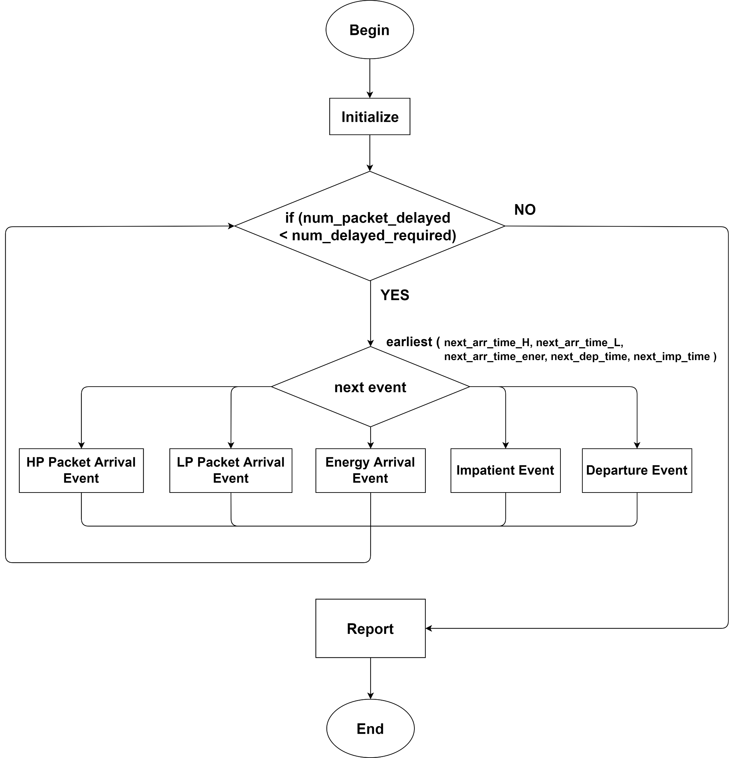

Fig. 4 - 1: Flow chart graphic of main program for scenario 1

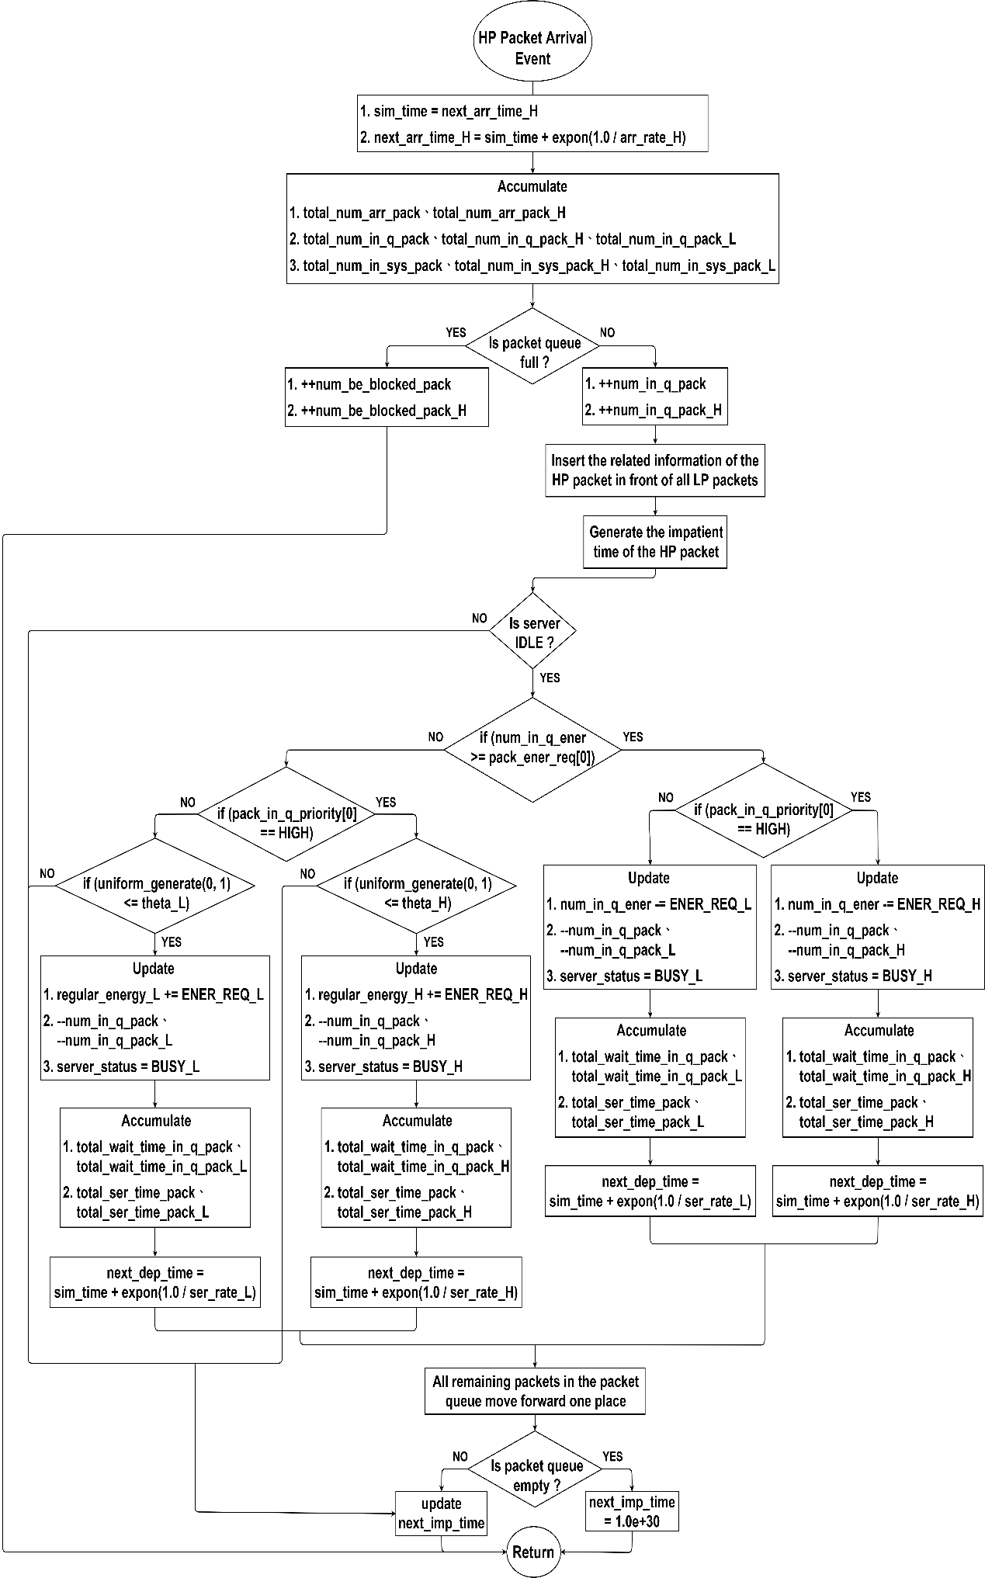

Fig. 4 - 2: Flow chart graphic of HP packet arrival subprogram for scenario 1

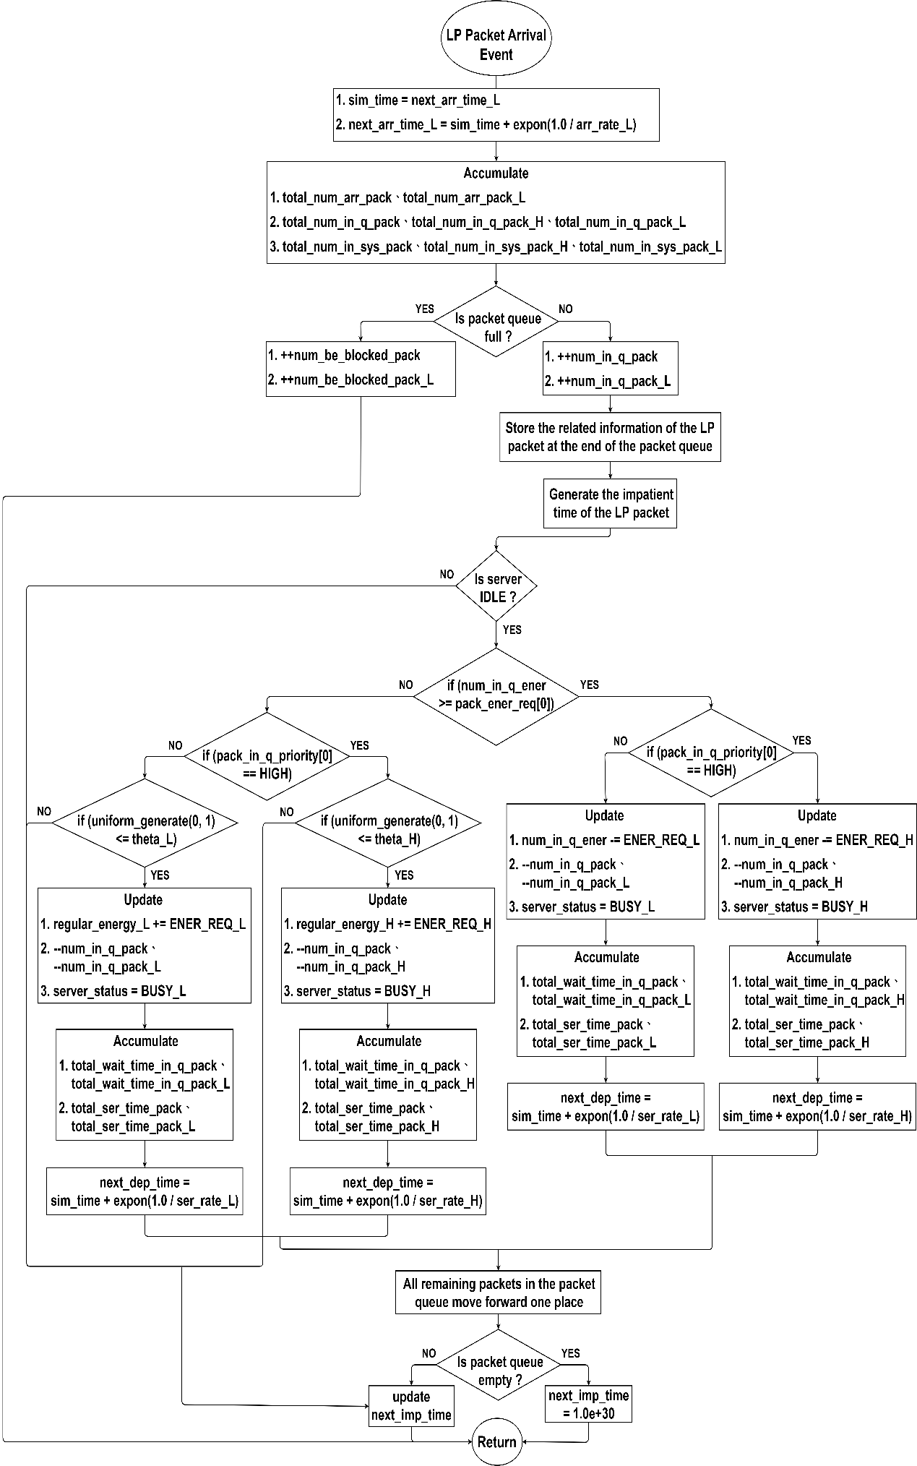

Fig. 4 - 3: Flow chart graphic of LP packet arrival subprogram for scenario 1

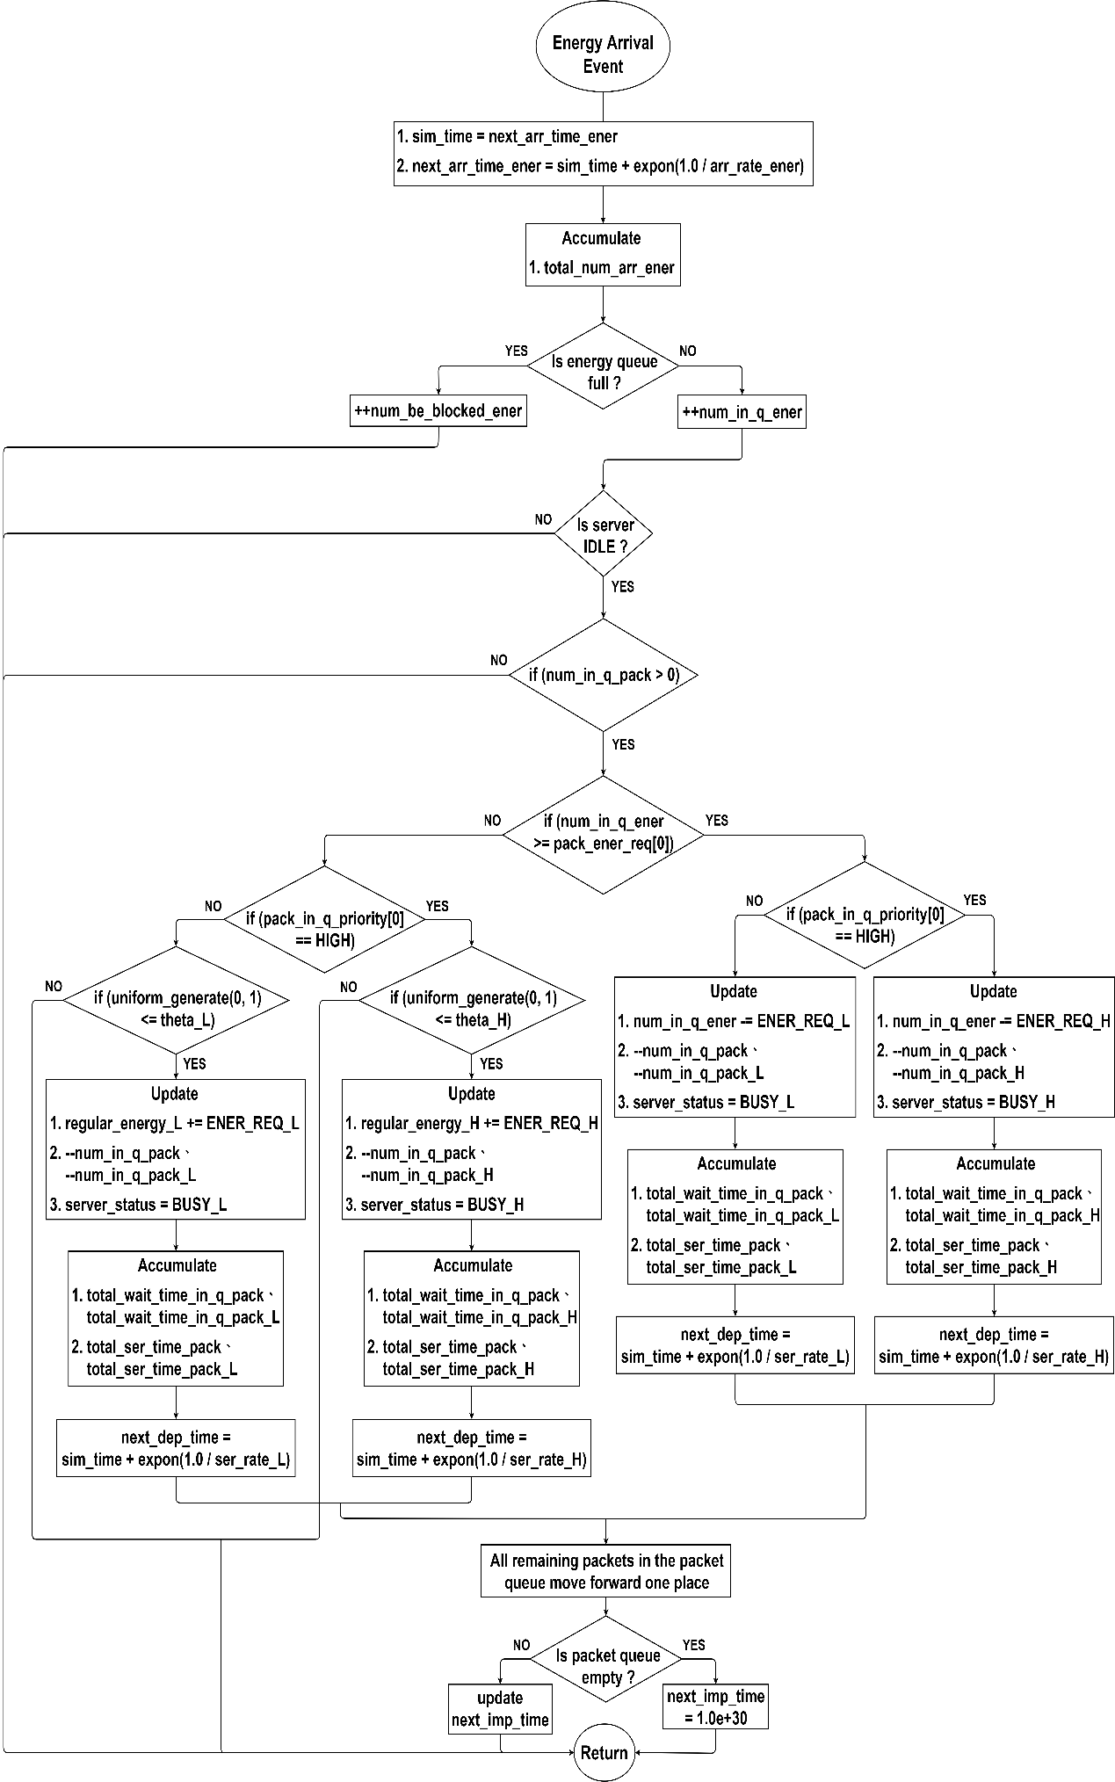

Fig. 4 - 4: Flow chart graphic of energy arrival subprogram for scenario 1

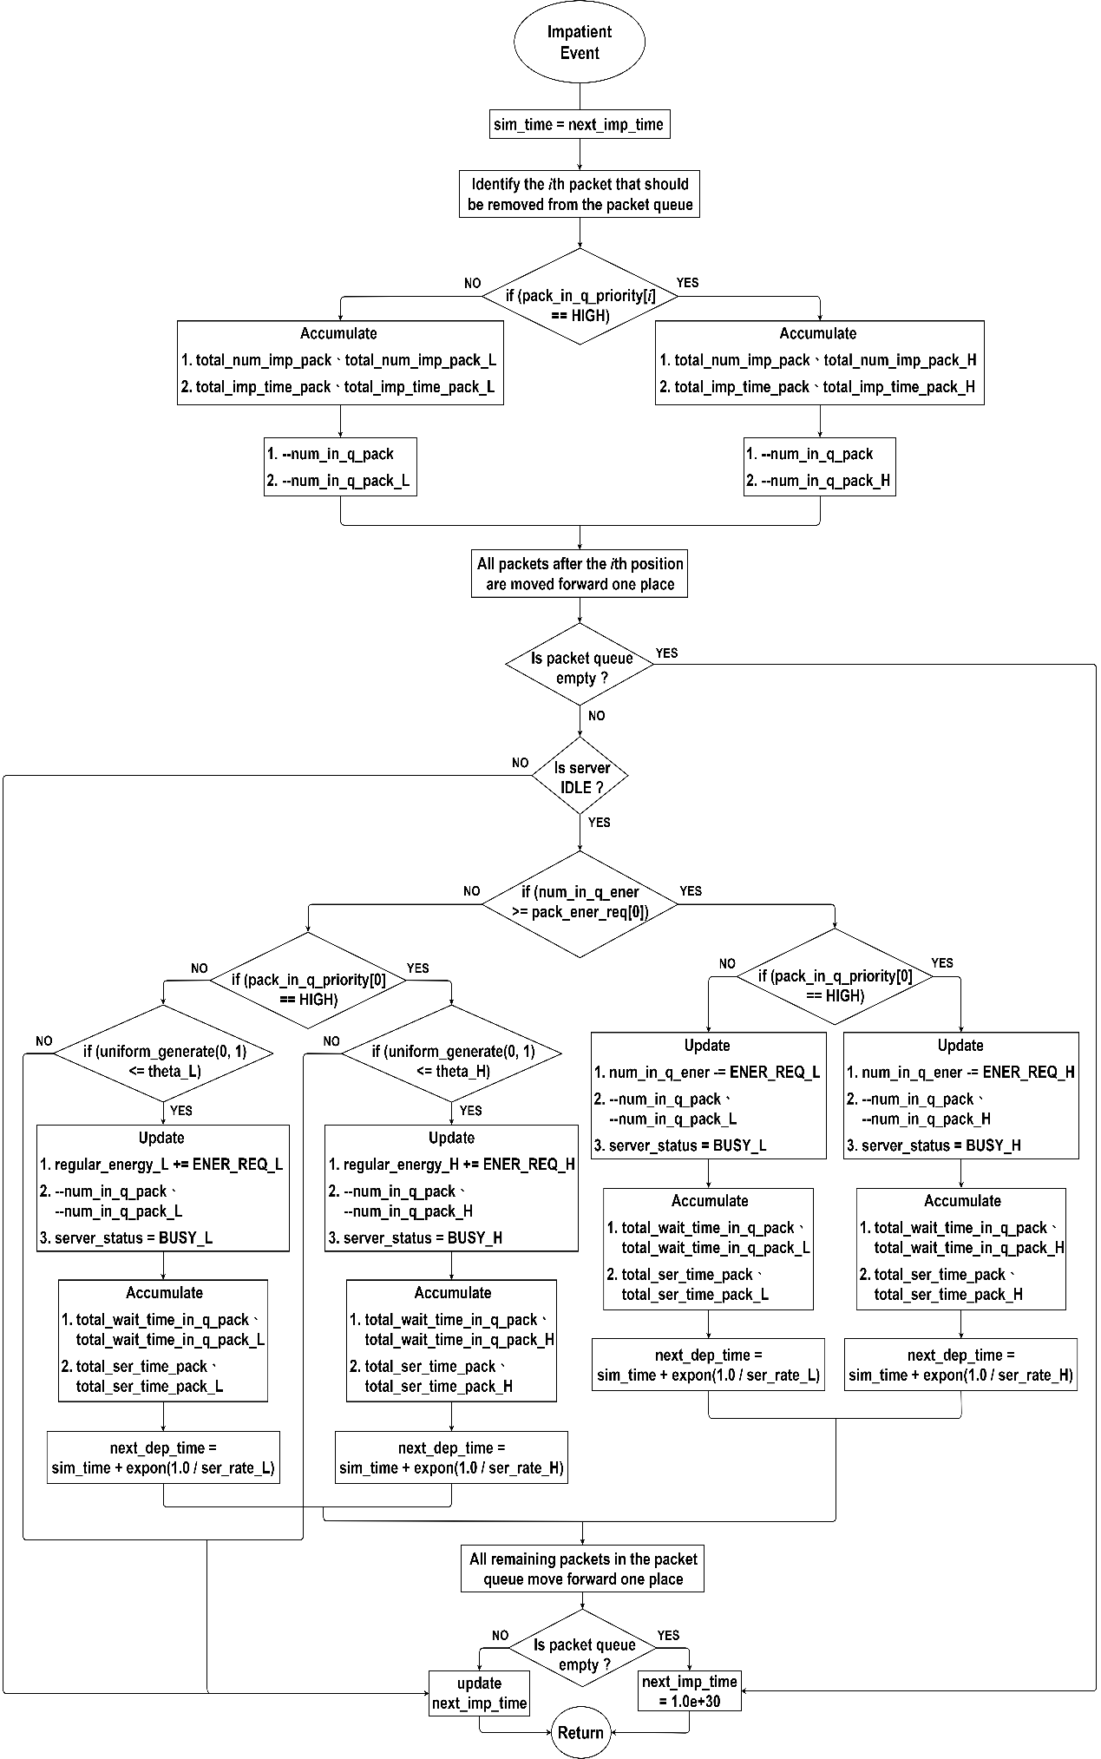

Fig. 4 - 5: Flow chart graphic of impatient subprogram for scenario 1

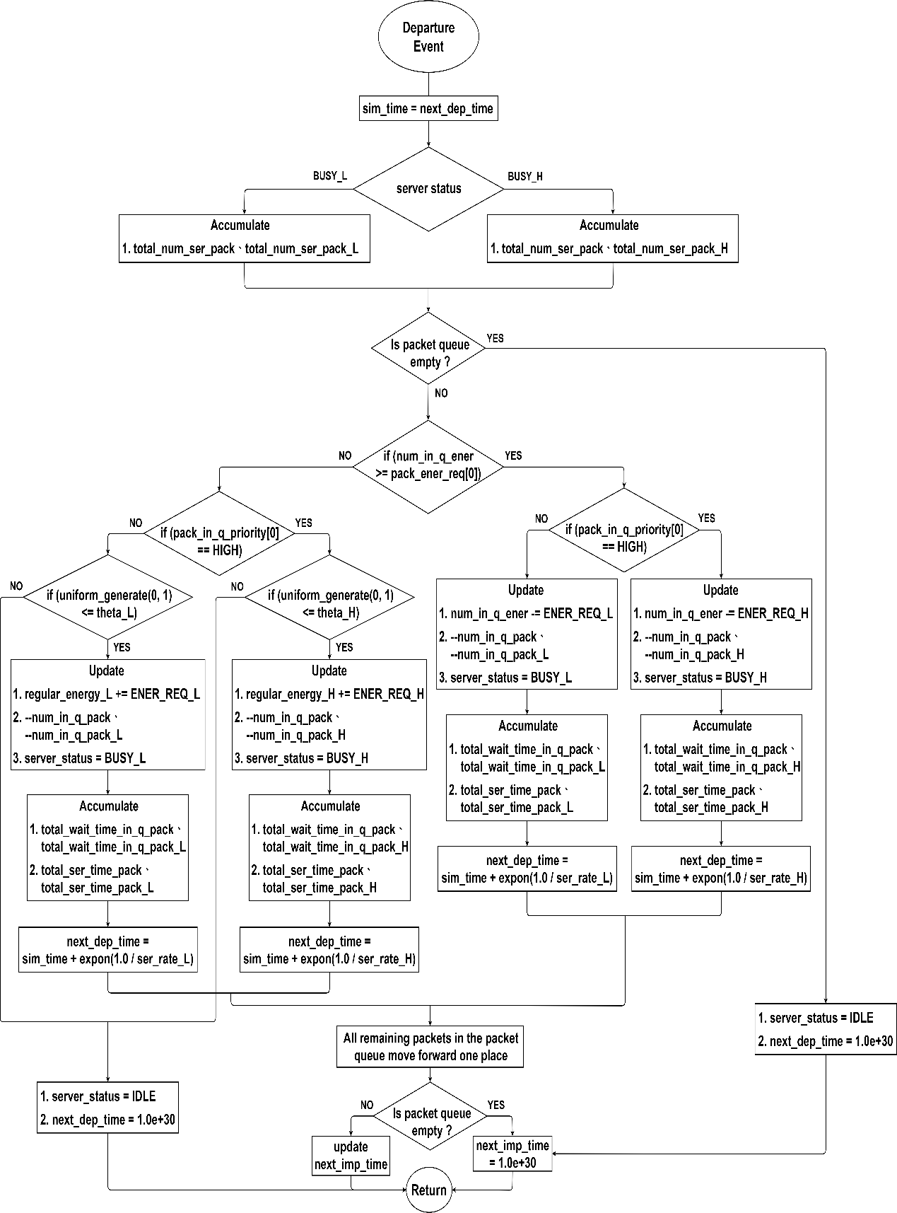

Fig. 4 - 6: Flow chart graphic of departure subprogram for scenario 1

## Scenario 2

In this scenario, there is only one sensor node considered. All packets within this scenario can be categorized into two priorities, where the energy requirement of an HP packet is different from that of an LP packet. Additionally, energy can be supplied by harvested energy or a regular battery. We divide the simulation into a main program and five subprograms for illustration.

### Main program

The flow chart graphic of the main program is shown in Fig. 4 - 7. In the first step, we initialize all variables that will be used. This includes setting the statistics parameters to "0", the next departure time to be "infinite", the server state to be "IDLE" and so on. Then the following parameters should be input via the keyboard: the capacity of packet queue $(N)$, the capacity of energy queue $(K)$, the mean arrival rate of energy units $(β)$, the mean arrival rates of HP and LP packets $(λ_{H},λ_{L})$, the mean service rates of HP and LP packets $(μ_{H},μ_{L})$, the mean impatient rates of HP and LP packets $(α_{H},α_{L})$, the probability of HP and LP packets using regular battery $(θ_{H},θ_{L})$, and the number of packets required. Meanwhile, the next energy arrival time and the next HP and LP packet arrival times will be generated with an exponential variate function according to the input values, respectively. In the second step, we compare the time of five events to determine the earliest, and then execute the corresponding subprogram. In the third step, a “while loop” is designed to repeat the second step until the total number of the served packets equals the number of packets required, after which the simulation ends with the performance results.

### HP packet arrival subprogram

The flow chart graphic of the HP packet arrival subprogram is shown in Fig. 4 - 8. In the beginning, the current simulation time is updated as the HP packet arrival time, and then we generate the next HP packet arrival time by the exponential variate function with $λ_{H}$. Besides, the total number of arrived packets, the total number of packets in the queue, and the total number of packets in the system are accumulated separately. Next, we determine whether the packet queue is full. If not, we increase the number of packets in the queue by one, then insert the related information of the HP packet in front of all LP packets and generate the impatient time by the exponential variate function with $α_{H}$. Conversely, if the queue is full, the number of blocked packets is increased by one. Afterwards, we divide the situation into the following cases for description.

1. First, the server will be checked if the status is “IDLE”. If not, we update the next impatient time based on the impatient times of packets in the queue. Otherwise, it is necessary to determine whether the number of energy units in the energy queue is greater than or equal to the energy requirement of the packet at the head of the packet queue.
2. Second, if the number of energy units in the energy queue is enough to serve the packet, we update various statuses and accumulate the relevant times according to the priority of the packet, such as, the number of energy units in the energy queue, the number of packets in the packet queue, the server status, the total waiting time in the queue and the total service time. After that, the departure time will be generated by the exponential variate function with . Then, all remaining packets in the packet queue move forward one place. Finally, we decide whether the next impatient time should be updated or set to be infinite, depending on if the packet queue is empty.
3. Third, if the number of energy units in the energy queue is insufficient, a random value between 0 and 1 is generated and compared with the regular battery usage probability . If it is less than or equal to , we update various statuses and accumulate the relevant times. This includes the number of energy units consumed from the regular battery, but not those in the energy queue. After that, the departure time will be generated by the exponential variate function with . Then, all remaining packets in the packet queue move forward one place. Finally, we decide whether the next impatient time should be updated or set to be infinite, depending on if the packet queue is empty.
4. Fourth, the number of energy units in the energy queue is insufficient, and the random value is greater than $θ_{H}/θ_{L}$, then we just need to update the next impatient time based on the impatient times of packets in the queue.

### LP packet arrival subprogram

The flow chart graphic of the LP packet arrival subprogram is shown in Fig. 4 - 9. In the beginning, the current simulation time is updated as the LP packet arrival time, and then we generate the next LP packet arrival time by the exponential variate function with $λ_{L}$. Besides, the total number of arrived packets, the total number of packets in the queue, and the total number of packets in the system are accumulated separately. Next, we determine whether the packet queue is full. If not, we increase the number of packets in the queue by one, then store the related information of the LP packet at the end of the packet queue and generate the impatient time by the exponential variate function with $α_{L}$. Conversely, if the queue is full, the number of blocked packets is increased by one. Afterwards, we divide the situation into the following cases for description.

1. First, the server will be checked if the status is “IDLE”. If not, we update the next impatient time based on the impatient times of packets in the queue. Otherwise, it is necessary to determine whether the number of energy units in the energy queue is greater than or equal to the energy requirement of the packet at the head of the packet queue.
2. Second, if the number of energy units in the energy queue is enough to serve the packet, we update various statuses and accumulate the relevant times according to the priority of the packet, such as, the number of energy units in the energy queue, the number of packets in the packet queue, the server status, the total waiting time in the queue and the total service time. After that, the departure time will be generated by the exponential variate function with . Then, all remaining packets in the packet queue move forward one place. Finally, we decide whether the next impatient time should be updated or set to be infinite, depending on if the packet queue is empty.
3. Third, if the number of energy units in the energy queue is insufficient, a random value between 0 and 1 is generated and compared with the regular battery usage probability . If it is less than or equal to , we update various statuses and accumulate the relevant times. This includes the number of energy units consumed from the regular battery, but not those in the energy queue. After that, the departure time will be generated by the exponential variate function with . Then, all remaining packets in the packet queue move forward one place. Finally, we decide whether the next impatient time should be updated or set to be infinite, depending on if the packet queue is empty.
4. Fourth, the number of energy units in the energy queue is insufficient, and the random value is greater than $θ_{H}/θ_{L}$, then we just need to update the next impatient time based on the impatient times of packets in the queue.

### Energy arrival subprogram

The flow chart graphic of the energy arrival subprogram is shown in Fig. 4 - 10. In the beginning, the current simulation time is updated as the energy arrival time, and then we generate the next energy arrival time by the exponential variate function with . Besides, the total number of arrived energy units is accumulated. Next, we determine whether the energy queue is full. If not, we increase the number of energy units in the energy queue by one. Conversely, if the energy queue is full, the number of blocked energy units is increased by one. Afterwards, the situation can be divided into the following cases for description.

1. First, we check sequentially if the server status is "IDLE" and if there are any packets in the packet queue. If both of the above conditions are met, then it is necessary to determine whether the number of energy units in the energy queue is greater than or equal to the energy requirement of the packet at the head of the packet queue. Otherwise, the subprogram will simply return to the main program without executing anything.
2. Second, if the number of energy units in the energy queue is enough to serve the packet, we update various statuses and accumulate the relevant times according to the priority of the packet, such as, the number of energy units in the energy queue, the number of packets in the packet queue, the server status, the total waiting time in the queue and the total service time. After that, the departure time will be generated by the exponential variate function with . Then, all remaining packets in the packet queue move forward one place. Finally, we decide whether the next impatient time should be updated or set to be infinite, depending on if the packet queue is empty.
3. Third, if the number of energy units in the energy queue is insufficient, a random value between 0 and 1 is generated and compared with the regular battery usage probability . If it is less than or equal to , we update various statuses and accumulate the relevant times. This includes the number of energy units consumed from the regular battery, but not those in the energy queue. After that, the departure time will be generated by the exponential variate function with . Then, all remaining packets in the packet queue move forward one place. Finally, we decide whether the next impatient time should be updated or set to be infinite, depending on if the packet queue is empty.
4. Fourth, the number of energy units in the energy queue is insufficient, and the random value is greater than the , then the subprogram will simply return to the main program without executing anything.

### Impatient subprogram

The flow chart graphic of the impatient subprogram is shown in Fig. 4 - 11. In the beginning, the current simulation time is updated as the next impatient time, and then we identify the $i$ th packet that should be removed from the packet queue due to impatience. In addition, the total number of impatient packets and total impatient time are accumulated based on the priority of the packet. Next, we reduce the number of packets in the queue by one and move all packets after the th position forward one place to overwrite the packet's original information. Afterwards, the situation can be divided into the following cases for description.

1. First, we check if the packet queue is empty. If so, the next impatient time is set to be infinite. Otherwise, we take one step further and check whether the server status is "IDLE" or not.
2. Second, if the server is busy, we update the next impatient time based on the impatient times of packets in the queue. On the contrary, it is necessary to determine whether the number of energy units in the energy queue is greater than or equal to the energy requirement of the packet at the head of the packet queue.
3. Third, if the number of energy units in the energy queue is enough to serve the packet, we update various statuses and accumulate the relevant times according to the priority of the packet, such as, the number of energy units in the energy queue, the number of packets in the packet queue, the server status, the total waiting time in the queue and the total service time. After that, the departure time will be generated by the exponential variate function with . Then, all remaining packets in the packet queue move forward one place. Finally, we decide whether the next impatient time should be updated or set to be infinite, depending on if the packet queue is empty.
4. Fourth, if the number of energy units in the energy queue is insufficient, a random value between 0 and 1 is generated and compared with the regular battery usage probability . If it is less than or equal to , we update various statuses and accumulate the relevant times. This includes the number of energy units consumed from the regular battery, but not those in the energy queue. After that, the departure time will be generated by the exponential variate function with . Then, all remaining packets in the packet queue move forward one place. Finally, we decide whether the next impatient time should be updated or set to be infinite, depending on if the packet queue is empty.
5. Fifth, the number of energy units in the energy queue is insufficient, and the random value is greater than $θ_{H}/θ_{L}$, then we only need to update the next impatient time based on the impatient times of packets in the queue.

### Departure subprogram

The flow chart graphic of the departure subprogram is shown in Fig. 4 - 12. In the beginning, the current simulation time is updated as the next departure time, and then we accumulate the total number of served packets based on the status of the server. Afterwards, the situation can be divided into the following cases for description.

1. First, we check if the packet queue is empty. If so, the server status is set to "IDLE" and the next departure time and the next impatient time are defined as infinite. Otherwise, it is necessary to determine whether the number of energy units in the energy queue is greater than or equal to the energy requirement of the packet at the head of the packet queue.
2. Second, if the number of energy units in the energy queue is enough to serve the packet, we update various statuses and accumulate the relevant times according to the priority of the packet, such as, the number of energy units in the energy queue, the number of packets in the packet queue, the server status, the total waiting time in the queue and the total service time. After that, the departure time will be generated by the exponential variate function with . Then, all remaining packets in the packet queue move forward one place. Finally, we decide whether the next impatient time should be updated or set to be infinite, depending on if the packet queue is empty.
3. Third, if the number of energy units in the energy queue is insufficient, a random value between 0 and 1 is generated and compared with the regular battery usage probability . If it is less than or equal to , we update various statuses and accumulate the relevant times. This includes the number of energy units consumed from the regular battery, but not those in the energy queue. After that, the departure time will be generated by the exponential variate function with . Then, all remaining packets in the packet queue move forward one place. Finally, we decide whether the next impatient time should be updated or set to be infinite, depending on if the packet queue is empty.
4. Fourth, the number of energy units in the energy queue is insufficient, and the random value is greater than $θ_{H}/θ_{L}$, then we just need to update the next impatient time based on the impatient times of packets in the queue.

### Performance measures

As a result of the simulation, we calculate various performance measures to estimate the effectiveness of the system model. The corresponding definitions are provided as follows:

1. Expected number of all packets in the system,

It indicates the average number of all packets in the system at the time when a packet arrives. The calculation formulas are given by

1. Expected number of all packets in the queue,

It indicates the average number of all packets in the packet queue at the time when a packet arrives. The calculation formulas are given by

1. Throughput,

It indicates the number of all packets that finish service and leave the system per unit time. The calculation formulas are given by

1. Mean waiting time in the system,

It indicates the average time of an arbitrary packet waiting in the system, which includes the queue time, the time in service, and the duration time before losing patience. The calculation formulas are given by

1. Blocking probability of all arrived packets,

It indicates the probability that all arrived packets cannot enter the system, since they arrive when the packet queue is full. The calculation formulas are given by

1. Energy loss probability,

It indicates the probability that the harvested energy units cannot enter the energy queue, since they arrive when the energy queue is full. The calculation formula is given by

1. Impatient loss probability of all arrived packets,

It indicates the probability that all arrived packets, including those blocked, leave the system due to impatience. The calculation formulas are given by

1. Impatient loss probability of all admitted packets,

It indicates the probability that all admitted packets, excluding those blocked, leave the system due to impatience. The calculation formulas are given by

1. Total loss probability of all arrived packets,

It indicates the probability that all arrived packets are dropped due to blocking or impatience. The calculation formulas are given by

1. Regular energy consumption ratio for serving all packets,

It indicates the ratio of the energy provided by the regular battery to the total energy consumption. The calculation formulas are given by

where "ENER_REQ_H" and "ENER_REQ_L" represent the number of energy units required for each HP and LP packet, respectively.



Fig. 4 - 7: Flow chart graphic of main program for scenario 2



Fig. 4 - 8: Flow chart graphic of HP packet arrival subprogram for scenario 2



Fig. 4 - 9: Flow chart graphic of LP packet arrival subprogram for scenario 2



Fig. 4 - 10: Flow chart graphic of energy arrival subprogram for scenario 2



Fig. 4 - 11: Flow chart graphic of impatient subprogram for scenario 2



Fig. 4 - 12: Flow chart graphic of departure subprogram for scenario 2

## Scenario 3

In this scenario, a three-connected-node network is considered. All packets within this scenario can be categorized into two priorities, both of which have the same energy requirement. Additionally, for each node, energy can be supplied by harvested energy or a regular battery. We divide the simulation into a main program and thirteen subprograms for illustration.

### Main program

The flow chart graphic of the main program is shown in Fig. 4 - 13. In the first step, we initialize all variables that will be used. This includes setting the statistics parameters to "0", all the next departure time to be "infinite", the server status of each node to be "IDLE" and so on. Then the following parameters for each node and the network should be input via the keyboard: the capacity of packet queue , the capacity of energy queue , the mean arrival rate of energy units , the mean service rates of HP and LP packets , the mean impatient rates of HP and LP packets , the probabilities of HP and LP packets using regular battery , the routing probabilities of and , and the number of packets required. Additionally, it should be noted that newly arrived packets from outside will only enter the network through the entry node; hence, we only need to consider the mean arrival rates of the HP and LP packets for the first node at the beginning. Afterwards, the next energy arrival time of each node and the next HP and LP packet arrival time of the first node will be generated with an exponential variate function according to the input values, respectively. In the second step, we compare the time of thirteen events to determine the earliest, and then execute the corresponding subprogram. In the third step, a “while loop” is designed to repeat the second step until the total number of the served packets equals the number of packets required, after which the simulation ends with the performance results.

### HP packet arrival subprogram

The flow chart graphic of HP packet arrival subprogram is shown in Fig. 4 - 14. In the beginning, the current simulation time is updated as the HP packet arrival time, and then we generate the next HP packet arrival time by the exponential variate function with . Besides, the total number of arrived packets for node 1 and the network, the total number of packets in the queue of node 1, and the total number of packets in node 1 are accumulated separately. Next, we determine whether the packet queue in node 1 is full. If not, we increase the number of packets in the queue by one, then insert the related information of the HP packet in front of all LP packets and generate the impatient time by the exponential variate function with . Conversely, if the queue is full, the number of blocked packets for node 1 is increased by one. Afterwards, we divide the situation into the following cases for description.

1. First, the server in node 1 will be checked if the status is “IDLE”. If not, we update the next impatient time based on the impatient time of packets in the queue. Otherwise, it is necessary to determine whether the number of energy units in the energy queue of node 1 is greater than or equal to the energy requirement of the packet at the head of the packet queue.
2. Second, if the number of energy units in the energy queue is enough to serve the packet, we update various statuses of node 1 and accumulate the relevant time according to the priority of the packet, such as, the number of energy units in the energy queue, the number of packets in the packet queue, the server status, the total waiting time in the queue and the total service time. After that, the departure time for node 1 will be generated by the exponential variate function with . Then, we temporarily store the information about whether the packet at the head of the queue has passed through node 3, and move all remaining packets in the packet queue one place forward. Finally, we decide whether the next impatient time should be updated or set to be infinite, depending on if the packet queue is empty.
3. Third, if the number of energy units in the energy queue is insufficient, a random value between 0 and 1 is generated and compared with the regular battery usage probability of node 1, i.e., . If it is less than or equal to , we update various statuses and accumulate the relevant time. This includes the number of energy units consumed from the regular battery, but not those in the energy queue. After that, the departure time for node 1 will be generated by the exponential variate function with . Then, we temporarily store the information about whether the packet at the head of the queue has passed through node 3, and move all remaining packets in the packet queue one place forward. Finally, we decide whether the next impatient time should be updated or set to be infinite, depending on if the packet queue is empty.
4. Fourth, the number of energy units in the energy queue is insufficient, and the random value is greater than , then we just need to update the next impatient time based on the impatient time of packets in the queue.

### LP packet arrival subprogram

The flow chart graphic of LP packet arrival subprogram is shown in Fig. 4 - 15. In the beginning, the current simulation time is updated as the LP packet arrival time, and then we generate the next LP packet arrival time by the exponential variate function with . Besides, the total number of arrived packets for node 1 and the network, the total number of packets in the queue of node 1, and the total number of packets in node 1 are accumulated separately. Next, we determine whether the packet queue in node 1 is full. If not, we increase the number of packets in the queue by one, then store the related information of the LP packet at the end of the packet queue and generate the impatient time by the exponential variate function with . Conversely, if the queue is full, the number of blocked packets for node 1 is increased by one. Afterwards, we divide the situation into the following cases for description.

1. First, the server in node 1 will be checked if the status is “IDLE”. If not, we update the next impatient time based on the impatient time of packets in the queue. Otherwise, it is necessary to determine whether the number of energy units in the energy queue of node 1 is greater than or equal to the energy requirement of the packet at the head of the packet queue.
2. Second, if the number of energy units in the energy queue is enough to serve the packet, we update various statuses of node 1 and accumulate the relevant time according to the priority of the packet, such as, the number of energy units in the energy queue, the number of packets in the packet queue, the server status, the total waiting time in the queue and the total service time. After that, the departure time for node 1 will be generated by the exponential variate function with . Then, we temporarily store the information about whether the packet at the head of the queue has passed through node 3, and move all remaining packets in the packet queue one place forward. Finally, we decide whether the next impatient time should be updated or set to be infinite, depending on if the packet queue is empty.
3. Third, if the number of energy units in the energy queue is insufficient, a random value between 0 and 1 is generated and compared with the regular battery usage probability of node 1, i.e., . If it is less than or equal to , we update various statuses and accumulate the relevant time. This includes the number of energy units consumed from the regular battery, but not those in the energy queue. After that, the departure time for node 1 will be generated by the exponential variate function with . Then, we temporarily store the information about whether the packet at the head of the queue has passed through node 3, and move all remaining packets in the packet queue one place forward. Finally, we decide whether the next impatient time should be updated or set to be infinite, depending on if the packet queue is empty.
4. Fourth, the number of energy units in the energy queue is insufficient, and the random value is greater than , then we just need to update the next impatient time based on the impatient time of packets in the queue.

### Node- $n$ energy arrival subprogram

The flow chart graphic of node- $n$ energy arrival subprogram is shown in Fig. 4 - 16. Since the energy arrival flow chart of each node is similar, to simplify the flowchart illustration here, we utilize node to represent each of the three nodes in the network. In the beginning, the current simulation time is updated as the energy arrival time of node , and then we generate the next energy arrival time by the exponential variate function with . Besides, the total number of arrived energy units for node is accumulated. Next, we determine whether the energy queue in node is full. If not, we increase the number of energy units in the energy queue by one. Conversely, if the energy queue is full, the number of blocked energy units for node is increased by one. Afterwards, the situation can be divided into the following cases for description.

1. First, we check sequentially if the server status in node is "IDLE" and if there are any packets in the packet queue of node . If both of the above conditions are met, then it is necessary to determine whether the number of energy units in the energy queue of node is greater than or equal to the energy requirement of the packet at the head of the packet queue. Otherwise, the subprogram will simply return to the main program without executing anything.
2. Second, if the number of energy units in the energy queue is enough to serve the packet, we update various statuses and accumulate the relevant time according to the priority of the packet and node , such as, the number of energy units in the energy queue, the number of packets in the packet queue, the server status, the total waiting time in the queue and the total service time. After that, the departure time for node will be generated by the exponential variate function with . Then, for the node in question, i.e., node 1 or 2, we temporarily store the information about whether the packet at the head of the queue passed through node 3; for node 3, we store the information of which node the packet came from. Afterwards, all remaining packets in the packet queue are moved forward one place. Finally, we decide whether the next impatient time should be updated or set to be infinite, depending on if the packet queue is empty.
3. Third, if the number of energy units in the energy queue is insufficient, a random value between 0 and 1 is generated and compared with the regular battery usage probability of node , i.e., . If it is less than or equal to , we update various statuses and accumulate the relevant time. This includes the number of energy units consumed from the regular battery, but not those in the energy queue. After that, the departure time for node will be generated by the exponential variate function with . Then, for the node in question, i.e., node 1 or 2, we temporarily store the information about whether the packet at the head of the queue passed through node 3; for node 3, we store the information of which node the packet came from. Afterwards, all remaining packets in the packet queue are moved forward one place. Finally, we decide whether the next impatient time should be updated or set to be infinite, depending on if the packet queue is empty.
4. Fourth, the number of energy units in the energy queue is insufficient, and the random value is greater than the , then the subprogram will simply return to the main program without executing anything.

### Packet arrival from node 3 to node $n$ subprogram

The flow chart graphic of the packet arrival from node 3 to node $n$ subprogram is shown in Fig. 4 - 17. Since the flow chart of the packet arrival from node 3 to other nodes is similar, to simplify the flowchart illustration here, we utilize node to represent each of node 1 and node 2 in the network. In the beginning, the current simulation time is updated as the packet arrival time from node 3 to node , and then we set the next packet arrival time from node 3 to node to be infinite. Besides, for node , the total number of arrived packets, the total number of packets in the queue, and the total number of packets in the node are separately accumulated according to the priority of the arrived packet. Next, we determine whether the packet queue in node is full. If not, we increase the number of packets in the queue by one, then insert the related information of the HP packet in front of all LP packets or store the information of the LP packet at the end of the queue, depending on the priority of the packet. After that, the impatient time is generated by the exponential variate function with , and the HPLP packet will be identified as “passed through node 3”. Conversely, if the queue is full, the number of blocked packets for node is increased by one. Afterwards, we divide the situation into the following cases for description.

1. First, the server in node will be checked if the status is “IDLE”. If not, we update the next impatient time based on the impatient time of packets in the queue. Otherwise, it is necessary to determine whether the number of energy units in the energy queue of node is greater than or equal to the energy requirement of the packet at the head of the packet queue.
2. Second, if the number of energy units in the energy queue is enough to serve the packet, we update various statuses and accumulate the relevant time according to the priority of the packet and node , such as, the number of energy units in the energy queue, the number of packets in the packet queue, the server status, the total waiting time in the queue and the total service time. After that, the departure time for node will be generated by the exponential variate function with . Then, we temporarily store the information about whether the packet at the head of the queue has passed through node 3, and move all remaining packets in the packet queue one place forward. Finally, we decide whether the next impatient time should be updated or set to be infinite, depending on if the packet queue is empty.
3. Third, if the number of energy units in the energy queue is insufficient, a random value between 0 and 1 is generated and compared with the regular battery usage probability of node , i.e., . If it is less than or equal to , we update various statuses and accumulate the relevant time. This includes the number of energy units consumed from the regular battery, but not those in the energy queue. After that, the departure time for node will be generated by the exponential variate function with . Then, we temporarily store the information about whether the packet at the head of the queue has passed through node 3, and move all remaining packets in the packet queue one place forward. Finally, we decide whether the next impatient time should be updated or set to be infinite, depending on if the packet queue is empty.
4. Fourth, the number of energy units in the energy queue of node is insufficient, and the random value is greater than , then we just need to update the next impatient time based on the impatient time of packets in the queue.

### Node- $n$ impatient subprogram

The flow chart graphic of node- $n$ impatient subprogram is shown in Fig. 4 - 18. Since the impatient flow chart of each node is similar, to simplify the flowchart illustration here, we utilize node to represent each of the three nodes in the network. In the beginning, the current simulation time is updated as the next impatient time of node , and then we identify the th packet that should be removed from the packet queue of node due to impatience. In addition, the total number of impatient packets and total impatient time are accumulated based on the priority of the packet. Next, we reduce the number of packets in the queue by one and move all packets after the th position forward one place to overwrite the packet's original information. Afterwards, the situation can be divided into the following cases for description.

1. First, we check if the packet queue is empty. If so, the next impatient time of node is set to be infinite. Otherwise, we take one step further and check whether the server status in node is "IDLE" or not.
2. Second, if the server is busy, we update the next impatient time of node based on the impatient time of packets in the queue. On the contrary, it is necessary to determine whether the number of energy units in the energy queue of node is greater than or equal to the energy requirement of the packet at the head of the packet queue.
3. Third, if the number of energy units in the energy queue is enough to serve the packet, we update various statuses and accumulate the relevant time according to the priority of the packet and node , such as, the number of energy units in the energy queue, the number of packets in the packet queue, the server status, the total waiting time in the queue and the total service time. After that, the departure time for node will be generated by the exponential variate function with . Then, for the node in question, i.e., node 1 or 2, we temporarily store the information about whether the packet at the head of the queue passed through node 3; for node 3, we store the information of which node the packet came from. Afterwards, all remaining packets in the packet queue are moved forward one place. Finally, we decide whether the next impatient time should be updated or set to be infinite, depending on if the packet queue is empty.
4. Fourth, if the number of energy units in the energy queue is insufficient, a random value between 0 and 1 is generated and compared with the regular battery usage probability of node , i.e., . If it is less than or equal to , we update various statuses and accumulate the relevant time. This includes the number of energy units consumed from the regular battery, but not those in the energy queue. After that, the departure time for node will be generated by the exponential variate function with . Then, for the node in question, i.e., node 1 or 2, we temporarily store the information about whether the packet at the head of the queue passed through node 3; for node 3, we store the information of which node the packet came from. Afterwards, all remaining packets in the packet queue are moved forward one place. Finally, we decide whether the next impatient time should be updated or set to be infinite, depending on if the packet queue is empty.
5. Fifth, the number of energy units in the energy queue is insufficient, and the random value is greater than , then we only need to update the next impatient time based on the impatient time of packets in the queue.

### Node-1 departure subprogram

The flow chart graphic of node-1 departure subprogram is shown in Fig. 4 - 19. In the beginning, the current simulation time is updated as the next departure time of node 1. Then we decide which node the packet will be routed to and update the corresponding arrival time based on whether it passed through node 3 and the routing probability . Next, according to the server status of node 1, the total number of served packets is accumulated and the priority of packet arriving at the next node is determined. Afterwards, we divide the situation into the following cases for description.

1. First, we check if the packet queue in node 1 is empty. If so, the server status is set to "IDLE", and the next departure time and the next impatient time for node 1 are defined as infinite. Otherwise, it is necessary to determine whether the number of energy units in the energy queue of node 1 is greater than or equal to the energy requirement of the packet at the head of the packet queue.
2. Second, if the number of energy units in the energy queue is enough to serve the packet, we update various statuses of node 1 and accumulate the relevant time according to the priority of the packet, such as, the number of energy units in the energy queue, the number of packets in the packet queue, the server status, the total waiting time in the queue and the total service time. After that, the departure time for node 1 will be generated by the exponential variate function with . Then, we temporarily store the information about whether the packet at the head of the queue has passed through node 3, and move all remaining packets in the packet queue one place forward. Finally, we decide whether the next impatient time should be updated or set to be infinite, depending on if the packet queue is empty.
3. Third, if the number of energy units in the energy queue is insufficient, a random value between 0 and 1 is generated and compared with the regular battery usage probability of node 1, i.e., . If it is less than or equal to , we update various statuses and accumulate the relevant time. This includes the number of energy units consumed from the regular battery, but not those in the energy queue. After that, the departure time for node 1 will be generated by the exponential variate function with . Then, we temporarily store the information about whether the packet at the head of the queue has passed through node 3, and move all remaining packets in the packet queue one place forward. Finally, we decide whether the next impatient time should be updated or set to be infinite, depending on if the packet queue is empty.
4. Fourth, the number of energy units in the energy queue of node 1 is insufficient, and the random value is greater than , then we need to set the server status to "IDLE" and the next departure time to infinite.

### Node-2 departure subprogram

The flow chart graphic of node-2 departure subprogram is shown in Fig. 4 - 20. In the beginning, the current simulation time is updated as the next departure time of node 2. Then, based on whether the packet passed through node 3 and the routing probability , we decide whether it should leave the network or be routed to node 3 with an update of the corresponding arrival time. Next, the total number of served packets is accumulated and the priority of packet arriving at the next node is determined according to the server status of node 2. Afterwards, we divide the situation into the following cases for description.

1. First, we check if the packet queue in node 2 is empty. If so, the server status is set to "IDLE", and the next departure time and the next impatient time for node 2 are defined as infinite. Otherwise, it is necessary to determine whether the number of energy units in the energy queue of node 2 is greater than or equal to the energy requirement of the packet at the head of the packet queue.
2. Second, if the number of energy units in the energy queue is enough to serve the packet, we update various statuses of node 2 and accumulate the relevant time according to the priority of the packet, such as, the number of energy units in the energy queue, the number of packets in the packet queue, the server status, the total waiting time in the queue and the total service time. After that, the departure time for node 2 will be generated by the exponential variate function with . Then, we temporarily store the information about whether the packet at the head of the queue has passed through node 3, and move all remaining packets in the packet queue one place forward. Finally, we decide whether the next impatient time should be updated or set to be infinite, depending on if the packet queue is empty.
3. Third, if the number of energy units in the energy queue is insufficient, a random value between 0 and 1 is generated and compared with the regular battery usage probability of node 2, i.e., . If it is less than or equal to , we update various statuses and accumulate the relevant time. This includes the number of energy units consumed from the regular battery, but not those in the energy queue. After that, the departure time for node 2 will be generated by the exponential variate function with . Then, we temporarily store the information about whether the packet at the head of the queue has passed through node 3, and move all remaining packets in the packet queue one place forward. Finally, we decide whether the next impatient time should be updated or set to be infinite, depending on if the packet queue is empty.
4. Fourth, the number of energy units in the energy queue of node 2 is insufficient, and the random value is greater than , then we need to set the server status to "IDLE" and the next departure time to infinite.

### Node-3 departure subprogram

The flow chart graphic of node-3 departure subprogram is shown in Fig. 4 - 21. In the beginning, the current simulation time is updated as the next departure time of node 3. Then, depending on which node the packet came from, we direct it back to the previous node with an update of the corresponding arrival time. Next, the total number of served packets is accumulated and the priority of packet arriving at the next node is determined according to the server status of node 3. Afterwards, we divide the situation into the following cases for description.

1. First, we check if the packet queue in node 3 is empty. If so, the server status is set to "IDLE", and the next departure time and the next impatient time for node 3 are defined as infinite. Otherwise, it is necessary to determine whether the number of energy units in the energy queue of node 3 is greater than or equal to the energy requirement of the packet at the head of the packet queue.
2. Second, if the number of energy units in the energy queue is enough to serve the packet, we update various statuses of node 3 and accumulate the relevant time according to the priority of the packet, such as, the number of energy units in the energy queue, the number of packets in the packet queue, the server status, the total waiting time in the queue and the total service time. After that, the departure time for node 3 will be generated by the exponential variate function with . Then, we temporarily store the information about which node the packet came from, and move all remaining packets in the packet queue one place forward. Finally, we decide whether the next impatient time should be updated or set to be infinite, depending on if the packet queue is empty.
3. Third, if the number of energy units in the energy queue is insufficient, a random value between 0 and 1 is generated and compared with the regular battery usage probability of node 3, i.e., . If it is less than or equal to , we update various statuses and accumulate the relevant time. This includes the number of energy units consumed from the regular battery, but not those in the energy queue. After that, the departure time for node 3 will be generated by the exponential variate function with . Then, we temporarily store the information about which node the packet came from, and move all remaining packets in the packet queue one place forward. Finally, we decide whether the next impatient time should be updated or set to be infinite, depending on if the packet queue is empty.
4. Fourth, the number of energy units in the energy queue of node 3 is insufficient, and the random value is greater than , then we need to set the server status to "IDLE" and the next departure time to infinite.

### Performance measures

As a result of the simulation, we calculate various performance measures to estimate the effectiveness of each node and the overall network. The corresponding definitions are provided as follows:

1. Expected number of all packets in node ,

It indicates the average number of all packets in node at the time when a packet arrives. The calculation formulas are given by

1. Expected number of all packets in the network,

It indicates the average number of all packets in the network at the time when a packet arrives. The calculation formulas are given by

1. Expected number of all packets in the queue of node ,

It indicates the average number of all packets in the packet queue of node at the time when a packet arrives. The calculation formulas are given by

1. Expected number of all packets in the queue,

It indicates the average number of all packets in the packet queue at the time when a packet arrives. The calculation formulas are given by

1. Throughput for node ,

It indicates the number of all packets that complete the service and leave node per unit time. The calculation formulas are given by

1. Throughput,

It indicates the number of all packets that complete the service and leave the network per unit time. The calculation formulas are given by

1. Mean waiting time in node ,

It indicates the average time of an arbitrary packet waiting in node , which includes the queue time, the time in service, and the duration time before losing patience. The calculation formulas are given by

1. Mean waiting time in the network,

It indicates the average time of an arbitrary packet waiting in the network, which includes the queue time, the time in service, and the duration time before losing patience. The calculation formulas are given by

1. Blocking probability of all arrived packets for node ,

It indicates the probability that all arrived packets cannot enter node , since they arrive when the packet queue is full. The calculation formulas are given by

1. Total blocking probability of all arrived packets,

It indicates the probability that all arrived packets cannot enter the network, since they arrive when the packet queue is full. The calculation formulas are given by

1. Energy loss probability for node ,

It indicates the probability that the harvested energy units cannot enter the energy queue of node , since they arrive when the energy queue is full. The calculation formula is given by

1. Total energy loss probability,

It indicates the probability that the harvested energy units cannot enter the energy queue, since they arrive when the energy queue is full. The calculation formula is given by

1. Impatient loss probability of all arrived packets for node ,

It indicates the probability that all arrived packets in node , including those blocked, leave the network due to impatience. The calculation formulas are given by

1. Total impatient loss probability of all arrived packets,

It indicates the probability that all arrived packets, including those blocked, leave the network due to impatience. The calculation formulas are given by

1. Impatient loss probability of all admitted packets for node ,

It indicates the probability that all admitted packets in node , excluding those blocked, leave the network due to impatience. The calculation formulas are given by

1. Total impatient loss probability of all admitted packets,

It indicates the probability that all admitted packets, excluding those blocked, leave the network due to impatience. The calculation formulas are given by

1. Total loss probability of all arrived packets for node ,

It indicates the probability that all arrived packets in node are dropped due to blocking or impatience. The calculation formulas are given by

1. Total loss probability of all arrived packets,

It indicates the probability that all arrived packets are dropped due to blocking or impatience. The calculation formulas are given by

1. Regular energy consumption ratio for serving all packets in node ,

It indicates the ratio of the energy provided by the regular battery to the total energy consumption for node . The calculation formulas are given by

where "ENER_REQ_H" and "ENER_REQ_L" represent the number of energy units required for each HP and LP packet, respectively.

1. Regular energy consumption ratio for serving all packets,

It indicates the ratio of the energy provided by the regular battery to the total energy consumption. The calculation formulas are given by

where "ENER_REQ_H" and "ENER_REQ_L" represent the number of energy units required for each HP and LP packet, respectively.

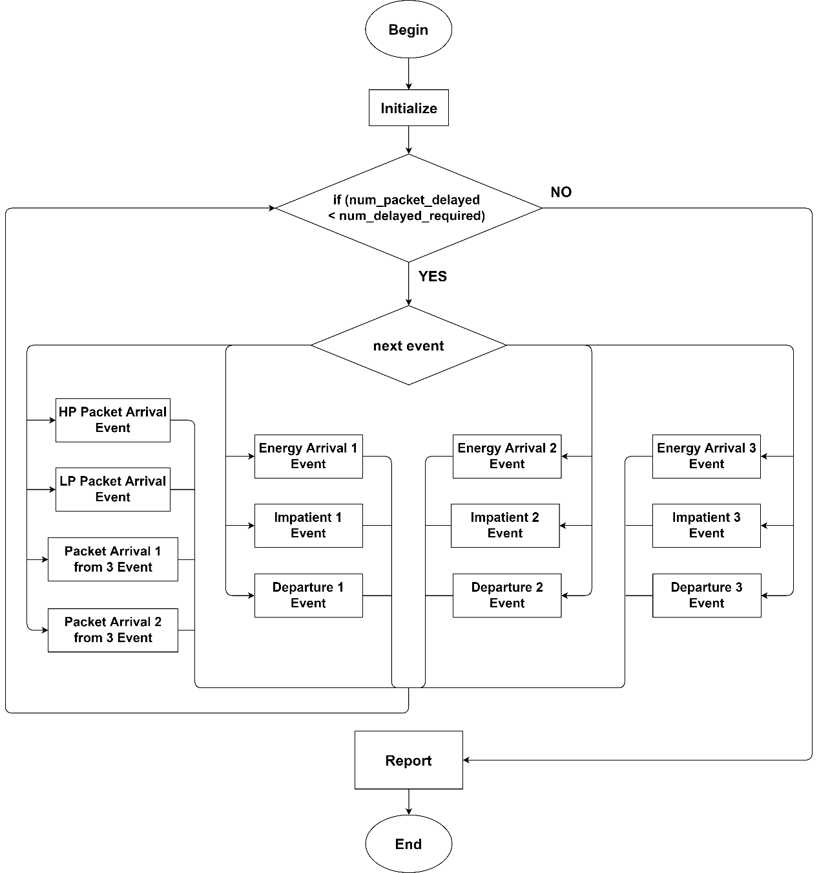

Fig. 4 - 13: Flow chart graphic of main program for scenario 3

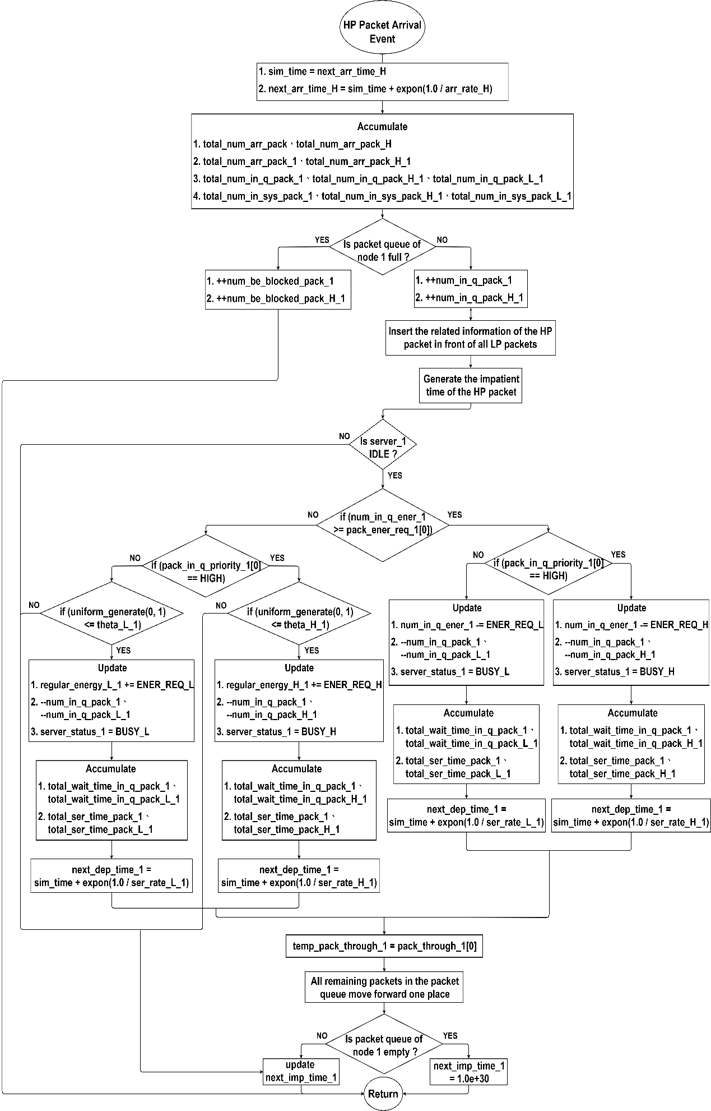

Fig. 4 - 14: Flow chart graphic of HP packet arrival subprogram for scenario 3

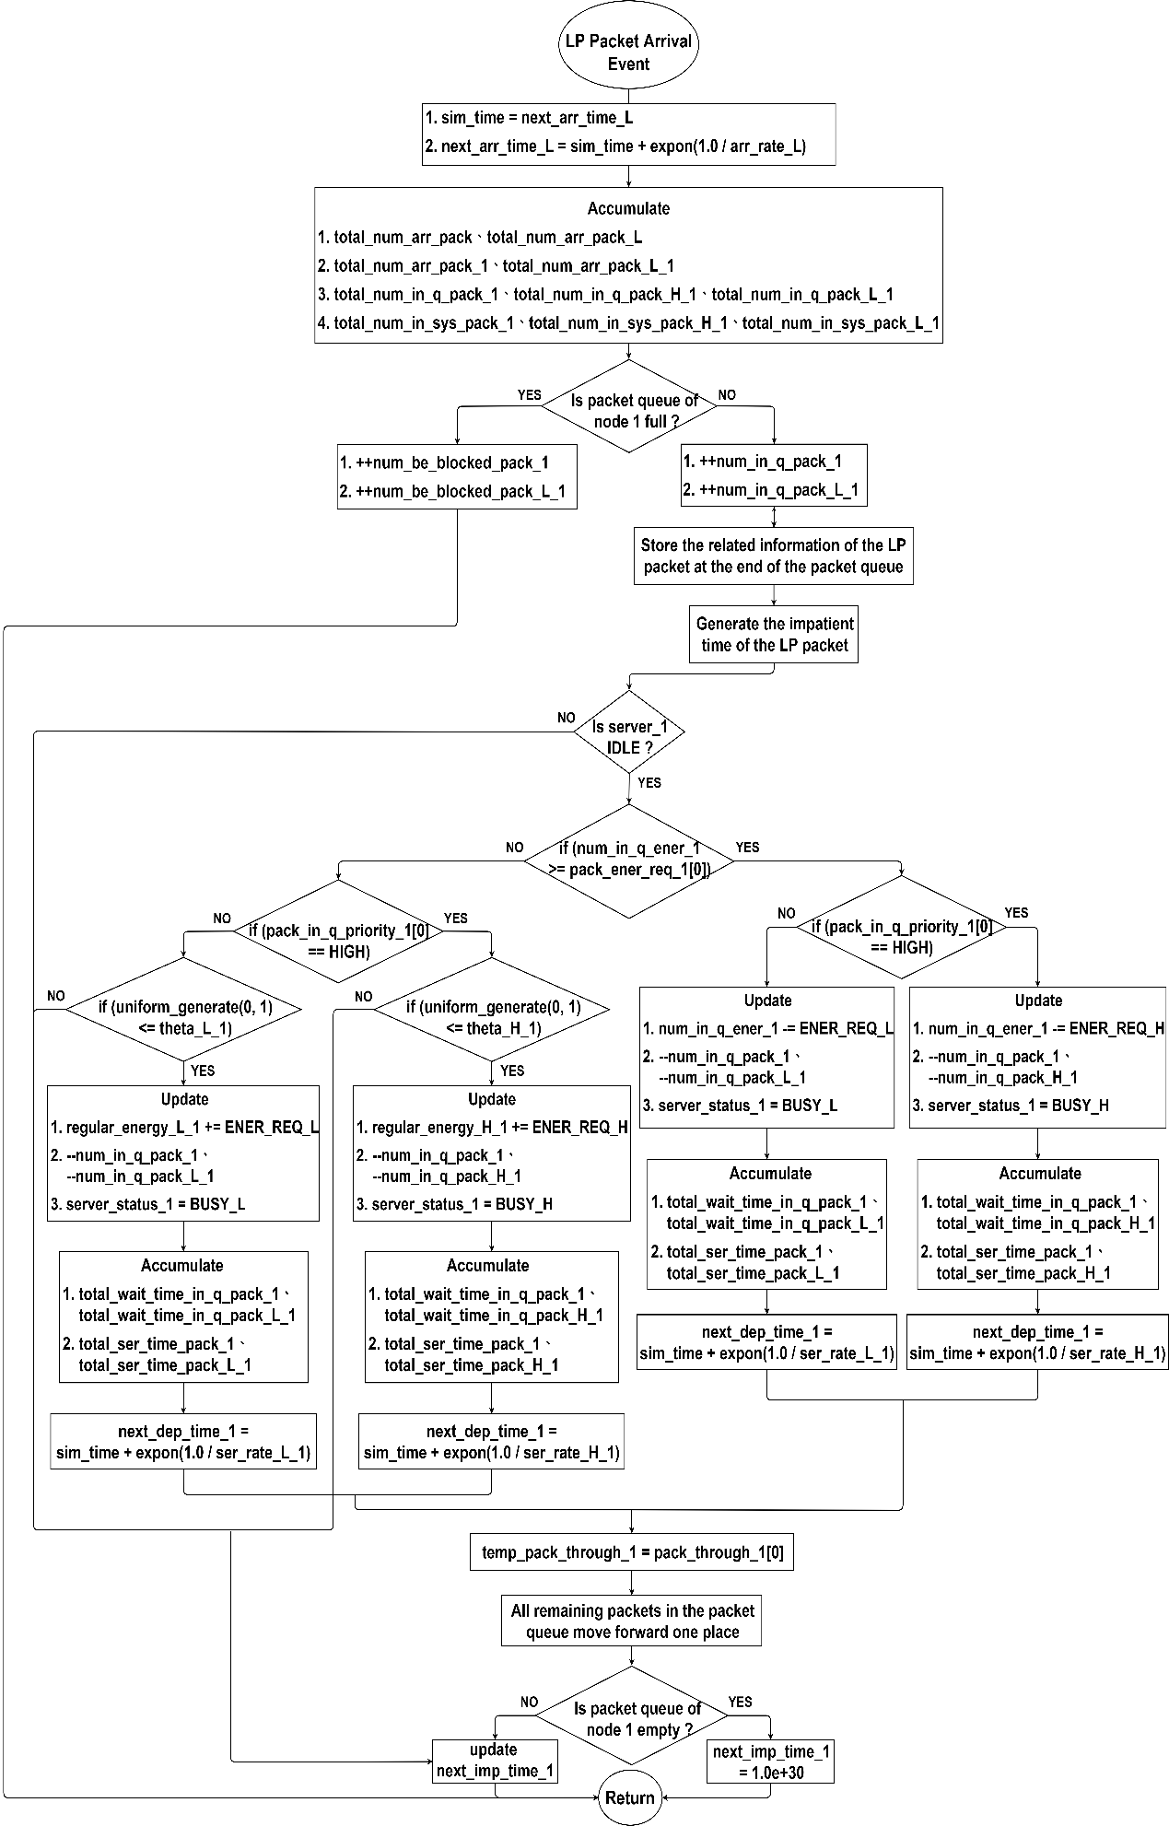

Fig. 4 - 15: Flow chart graphic of LP packet arrival subprogram for scenario 3

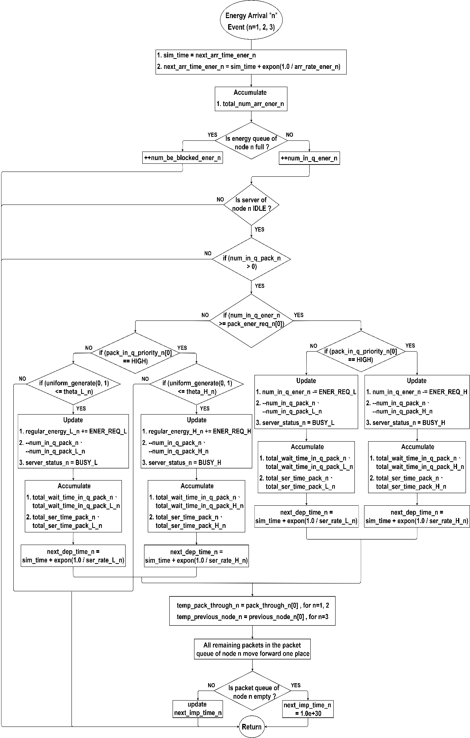

Fig. 4 - 16: Flow chart graphic of node-n energy arrival subprogram for scenario 3

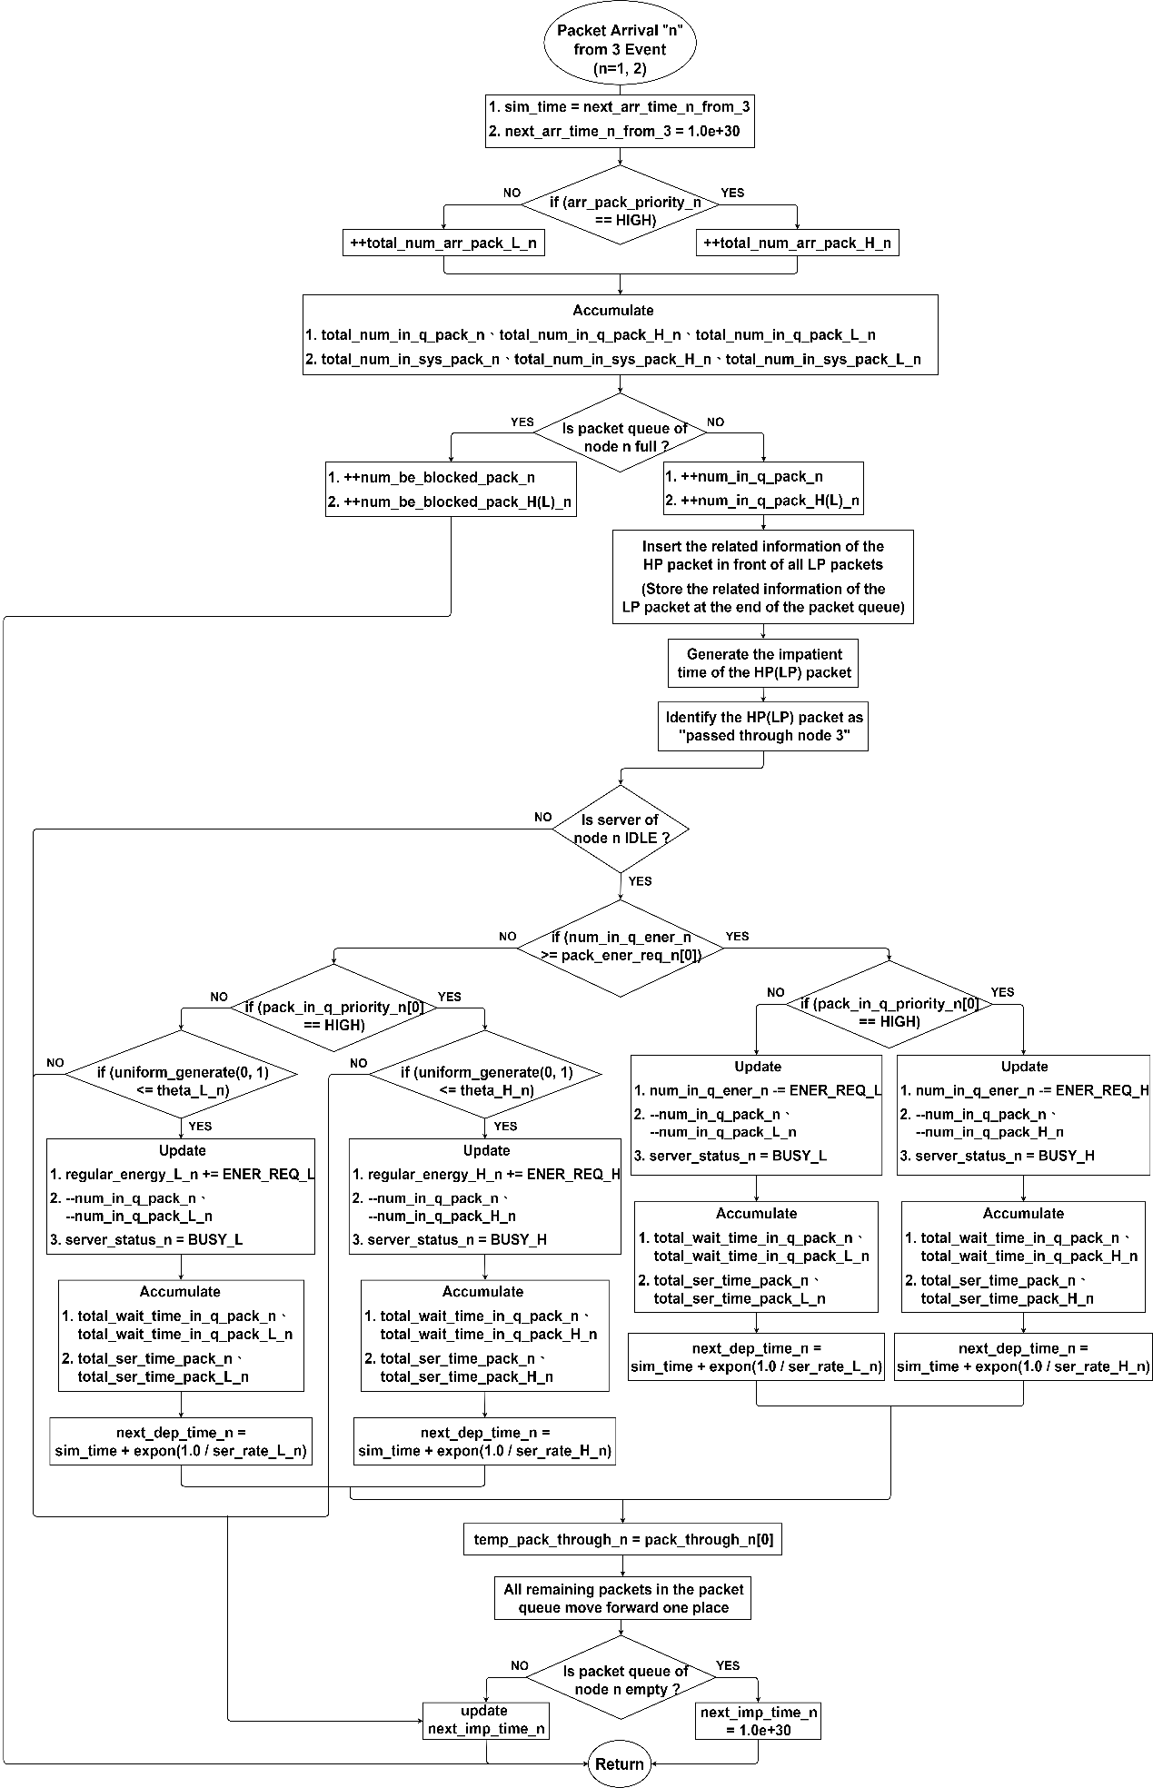

Fig. 4 - 17: Flow chart graphic of the packet arrival from node 3 to node $n$ subprogram for scenario 3

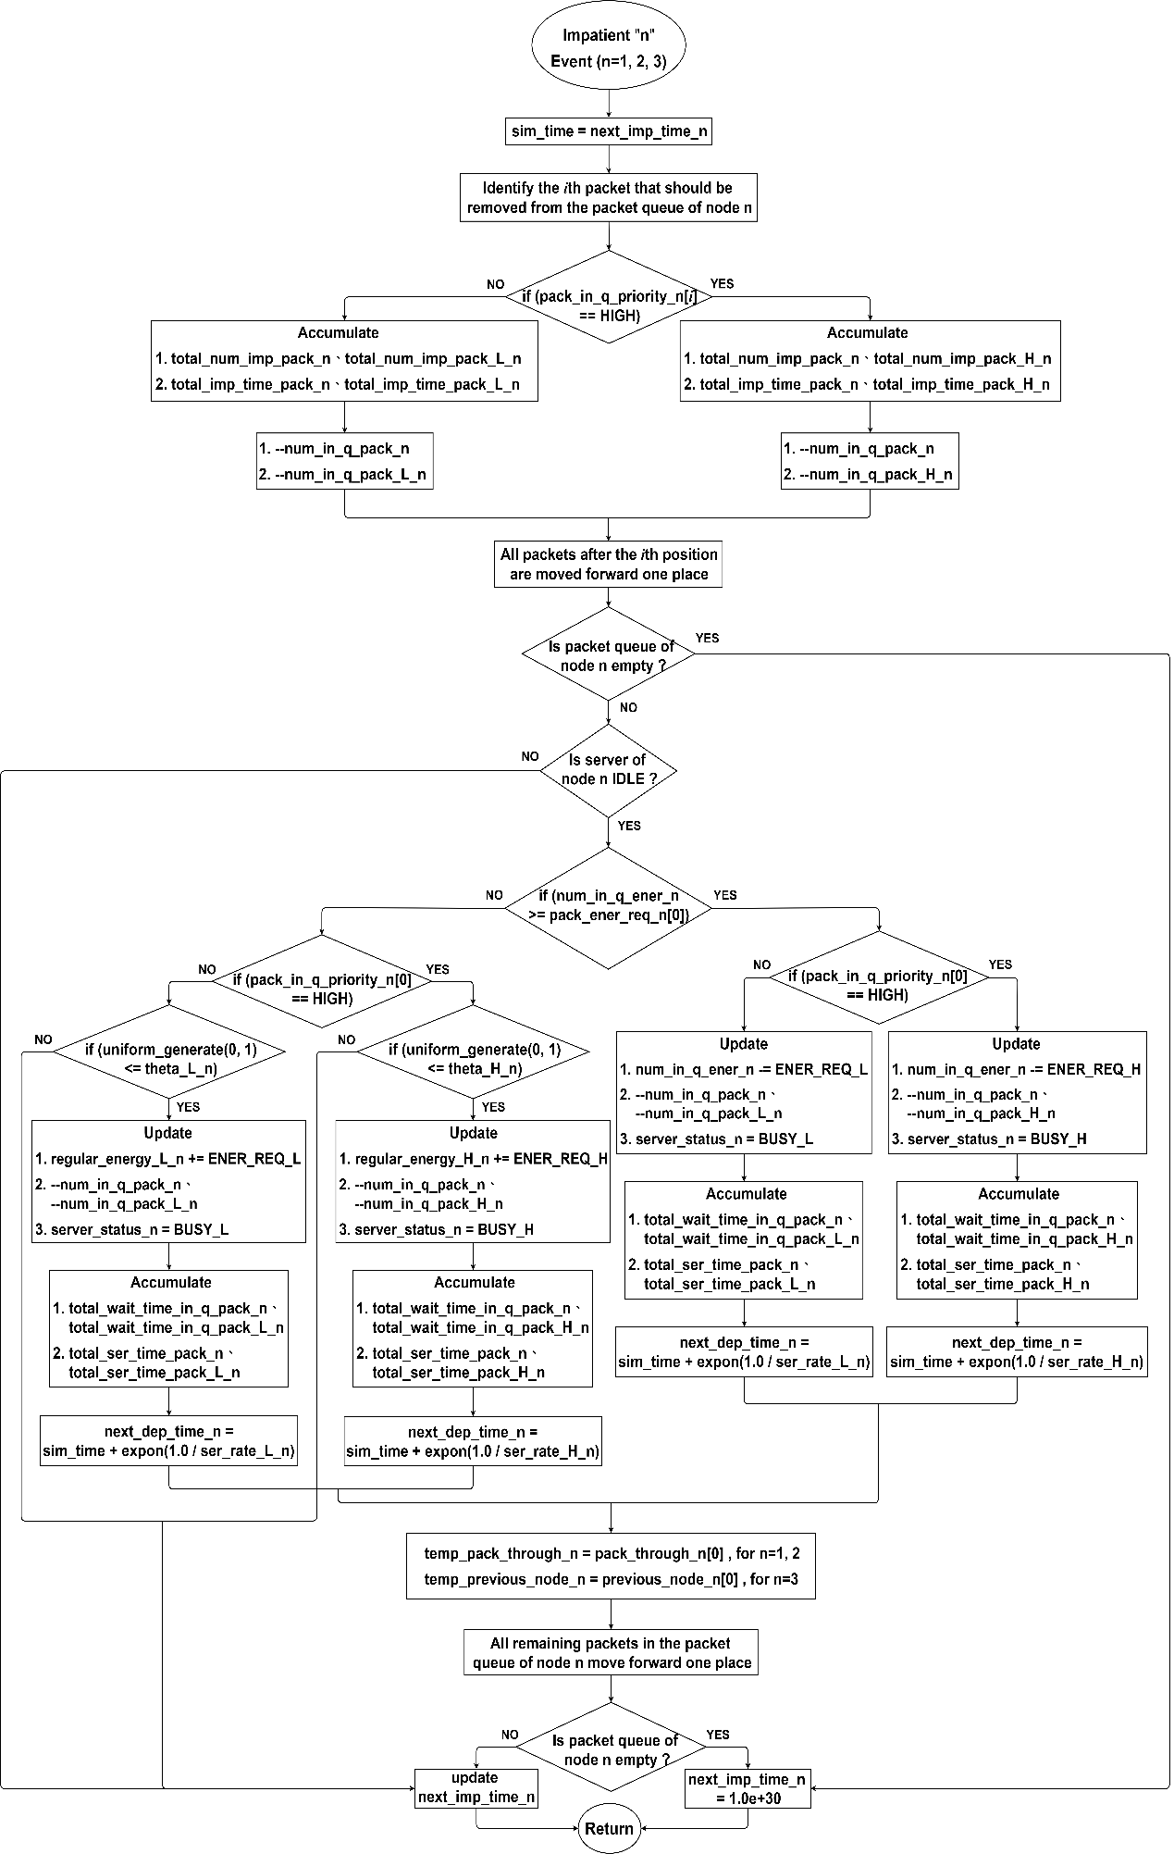

Fig. 4 - 18: Flow chart graphic of node-n impatient subprogram for scenario 3



Fig. 4 - 19: Flow chart graphic of node-1 departure subprogram for scenario 3



Fig. 4 - 20: Flow chart graphic of node-2 departure subprogram for scenario 3



Fig. 4 - 21: Flow chart graphic of node-3 departure subprogram for scenario 3

## Scenario 4

In this scenario, a three-connected-node network is considered. All packets within this scenario can be categorized into two priorities, where the energy requirement of an HP packet is different from that of an LP packet. Additionally, for each node, energy can be supplied by harvested energy or a regular battery. We divide the simulation into a main program and thirteen subprograms for illustration.

### Main program

The flow chart graphic of the main program is shown in Fig. 4 - 22. In the first step, we initialize all variables that will be used. This includes setting the statistics parameters to "0", all the next departure time to be "infinite", the server status of each node to be "IDLE" and so on. Then the following parameters for each node and the network should be input via the keyboard: the capacity of packet queue , the capacity of energy queue , the mean arrival rate of energy units , the mean service rates of HP and LP packets , the mean impatient rates of HP and LP packets , the probabilities of HP and LP packets using regular battery , the routing probabilities of and , and the number of packets required. Additionally, it should be noted that newly arrived packets from outside will only enter the network through the entry node; hence, we only need to consider the mean arrival rates of the HP and LP packets for the first node at the beginning. Afterwards, the next energy arrival time of each node and the next HP and LP packet arrival time of the first node will be generated with an exponential variate function according to the input values, respectively. In the second step, we compare the time of thirteen events to determine the earliest, and then execute the corresponding subprogram. In the third step, a “while loop” is designed to repeat the second step until the total number of the served packets equals the number of packets required, after which the simulation ends with the performance results.

### HP packet arrival subprogram

The flow chart graphic of HP packet arrival subprogram is shown in Fig. 4 - 23. In the beginning, the current simulation time is updated as the HP packet arrival time, and then we generate the next HP packet arrival time by the exponential variate function with . Besides, the total number of arrived packets for node 1 and the network, the total number of packets in the queue of node 1, and the total number of packets in node 1 are accumulated separately. Next, we determine whether the packet queue in node 1 is full. If not, we increase the number of packets in the queue by one, then insert the related information of the HP packet in front of all LP packets and generate the impatient time by the exponential variate function with . Conversely, if the queue is full, the number of blocked packets for node 1 is increased by one. Afterwards, we divide the situation into the following cases for description.

1. First, the server in node 1 will be checked if the status is “IDLE”. If not, we update the next impatient time based on the impatient time of packets in the queue. Otherwise, it is necessary to determine whether the number of energy units in the energy queue of node 1 is greater than or equal to the energy requirement of the packet at the head of the packet queue.
2. Second, if the number of energy units in the energy queue is enough to serve the packet, we update various statuses of node 1 and accumulate the relevant time according to the priority of the packet, such as, the number of energy units in the energy queue, the number of packets in the packet queue, the server status, the total waiting time in the queue and the total service time. After that, the departure time for node 1 will be generated by the exponential variate function with . Then, we temporarily store the information about whether the packet at the head of the queue has passed through node 3, and move all remaining packets in the packet queue one place forward. Finally, we decide whether the next impatient time should be updated or set to be infinite, depending on if the packet queue is empty.
3. Third, if the number of energy units in the energy queue is insufficient, a random value between 0 and 1 is generated and compared with the regular battery usage probability of node 1, i.e., . If it is less than or equal to , we update various statuses and accumulate the relevant time. This includes the number of energy units consumed from the regular battery, but not those in the energy queue. After that, the departure time for node 1 will be generated by the exponential variate function with . Then, we temporarily store the information about whether the packet at the head of the queue has passed through node 3, and move all remaining packets in the packet queue one place forward. Finally, we decide whether the next impatient time should be updated or set to be infinite, depending on if the packet queue is empty.
4. Fourth, the number of energy units in the energy queue is insufficient, and the random value is greater than , then we just need to update the next impatient time based on the impatient time of packets in the queue.

### LP packet arrival subprogram

The flow chart graphic of LP packet arrival subprogram is shown in Fig. 4 - 24. In the beginning, the current simulation time is updated as the LP packet arrival time, and then we generate the next LP packet arrival time by the exponential variate function with . Besides, the total number of arrived packets for node 1 and the network, the total number of packets in the queue of node 1, and the total number of packets in node 1 are accumulated separately. Next, we determine whether the packet queue in node 1 is full. If not, we increase the number of packets in the queue by one, then store the related information of the LP packet at the end of the packet queue and generate the impatient time by the exponential variate function with . Conversely, if the queue is full, the number of blocked packets for node 1 is increased by one. Afterwards, we divide the situation into the following cases for description.

1. First, the server in node 1 will be checked if the status is “IDLE”. If not, we update the next impatient time based on the impatient time of packets in the queue. Otherwise, it is necessary to determine whether the number of energy units in the energy queue of node 1 is greater than or equal to the energy requirement of the packet at the head of the packet queue.
2. Second, if the number of energy units in the energy queue is enough to serve the packet, we update various statuses of node 1 and accumulate the relevant time according to the priority of the packet, such as, the number of energy units in the energy queue, the number of packets in the packet queue, the server status, the total waiting time in the queue and the total service time. After that, the departure time for node 1 will be generated by the exponential variate function with . Then, we temporarily store the information about whether the packet at the head of the queue has passed through node 3, and move all remaining packets in the packet queue one place forward. Finally, we decide whether the next impatient time should be updated or set to be infinite, depending on if the packet queue is empty.
3. Third, if the number of energy units in the energy queue is insufficient, a random value between 0 and 1 is generated and compared with the regular battery usage probability of node 1, i.e., . If it is less than or equal to , we update various statuses and accumulate the relevant time. This includes the number of energy units consumed from the regular battery, but not those in the energy queue. After that, the departure time for node 1 will be generated by the exponential variate function with . Then, we temporarily store the information about whether the packet at the head of the queue has passed through node 3, and move all remaining packets in the packet queue one place forward. Finally, we decide whether the next impatient time should be updated or set to be infinite, depending on if the packet queue is empty.
4. Fourth, the number of energy units in the energy queue is insufficient, and the random value is greater than , then we just need to update the next impatient time based on the impatient time of packets in the queue.

### Node- $n$ energy arrival subprogram

The flow chart graphic of node- $n$ energy arrival subprogram is shown in Fig. 4 - 25. Since the energy arrival flow chart of each node is similar, to simplify the flowchart illustration here, we utilize node to represent each of the three nodes in the network. In the beginning, the current simulation time is updated as the energy arrival time of node , and then we generate the next energy arrival time by the exponential variate function with . Besides, the total number of arrived energy units for node is accumulated. Next, we determine whether the energy queue in node is full. If not, we increase the number of energy units in the energy queue by one. Conversely, if the energy queue is full, the number of blocked energy units for node is increased by one. Afterwards, the situation can be divided into the following cases for description.

1. First, we check sequentially if the server status in node is "IDLE" and if there are any packets in the packet queue of node . If both of the above conditions are met, then it is necessary to determine whether the number of energy units in the energy queue of node is greater than or equal to the energy requirement of the packet at the head of the packet queue. Otherwise, the subprogram will simply return to the main program without executing anything.
2. Second, if the number of energy units in the energy queue is enough to serve the packet, we update various statuses and accumulate the relevant time according to the priority of the packet and node , such as, the number of energy units in the energy queue, the number of packets in the packet queue, the server status, the total waiting time in the queue and the total service time. After that, the departure time for node will be generated by the exponential variate function with . Then, for the node in question, i.e., node 1 or 2, we temporarily store the information about whether the packet at the head of the queue passed through node 3; for node 3, we store the information of which node the packet came from. Afterwards, all remaining packets in the packet queue are moved forward one place. Finally, we decide whether the next impatient time should be updated or set to be infinite, depending on if the packet queue is empty.
3. Third, if the number of energy units in the energy queue is insufficient, a random value between 0 and 1 is generated and compared with the regular battery usage probability of node , i.e., . If it is less than or equal to , we update various statuses and accumulate the relevant time. This includes the number of energy units consumed from the regular battery, but not those in the energy queue. After that, the departure time for node will be generated by the exponential variate function with . Then, for the node in question, i.e., node 1 or 2, we temporarily store the information about whether the packet at the head of the queue passed through node 3; for node 3, we store the information of which node the packet came from. Afterwards, all remaining packets in the packet queue are moved forward one place. Finally, we decide whether the next impatient time should be updated or set to be infinite, depending on if the packet queue is empty.
4. Fourth, the number of energy units in the energy queue is insufficient, and the random value is greater than the , then the subprogram will simply return to the main program without executing anything.

### Packet arrival from node 3 to node $n$ subprogram

The flow chart graphic of the packet arrival from node 3 to node $n$ subprogram is shown in Fig. 4 - 26. Since the flow chart of the packet arrival from node 3 to other nodes is similar, to simplify the flowchart illustration here, we utilize node to represent each of node 1 and node 2 in the network. In the beginning, the current simulation time is updated as the packet arrival time from node 3 to node , and then we set the next packet arrival time from node 3 to node to be infinite. Besides, for node , the total number of arrived packets, the total number of packets in the queue, and the total number of packets in the node are separately accumulated according to the priority of the arrived packet. Next, we determine whether the packet queue in node is full. If not, we increase the number of packets in the queue by one, then insert the related information of the HP packet in front of all LP packets or store the information of the LP packet at the end of the queue, depending on the priority of the packet. After that, the impatient time is generated by the exponential variate function with , and the HPLP packet will be identified as “passed through node 3”. Conversely, if the queue is full, the number of blocked packets for node is increased by one. Afterwards, we divide the situation into the following cases for description.

1. First, the server in node will be checked if the status is “IDLE”. If not, we update the next impatient time based on the impatient time of packets in the queue. Otherwise, it is necessary to determine whether the number of energy units in the energy queue of node is greater than or equal to the energy requirement of the packet at the head of the packet queue.
2. Second, if the number of energy units in the energy queue is enough to serve the packet, we update various statuses and accumulate the relevant time according to the priority of the packet and node , such as, the number of energy units in the energy queue, the number of packets in the packet queue, the server status, the total waiting time in the queue and the total service time. After that, the departure time for node will be generated by the exponential variate function with . Then, we temporarily store the information about whether the packet at the head of the queue has passed through node 3, and move all remaining packets in the packet queue one place forward. Finally, we decide whether the next impatient time should be updated or set to be infinite, depending on if the packet queue is empty.
3. Third, if the number of energy units in the energy queue is insufficient, a random value between 0 and 1 is generated and compared with the regular battery usage probability of node , i.e., . If it is less than or equal to , we update various statuses and accumulate the relevant time. This includes the number of energy units consumed from the regular battery, but not those in the energy queue. After that, the departure time for node will be generated by the exponential variate function with . Then, we temporarily store the information about whether the packet at the head of the queue has passed through node 3, and move all remaining packets in the packet queue one place forward. Finally, we decide whether the next impatient time should be updated or set to be infinite, depending on if the packet queue is empty.
4. Fourth, the number of energy units in the energy queue of node is insufficient, and the random value is greater than , then we just need to update the next impatient time based on the impatient time of packets in the queue.

### Node- $n$ impatient subprogram

The flow chart graphic of node- $n$ impatient subprogram is shown in Fig. 4 - 27. Since the impatient flow chart of each node is similar, to simplify the flowchart illustration here, we utilize node to represent each of the three nodes in the network. In the beginning, the current simulation time is updated as the next impatient time of node , and then we identify the th packet that should be removed from the packet queue of node due to impatience. In addition, the total number of impatient packets and total impatient time are accumulated based on the priority of the packet. Next, we reduce the number of packets in the queue by one and move all packets after the th position forward one place to overwrite the packet's original information. Afterwards, the situation can be divided into the following cases for description.

1. First, we check if the packet queue is empty. If so, the next impatient time of node is set to be infinite. Otherwise, we take one step further and check whether the server status in node is "IDLE" or not.
2. Second, if the server is busy, we update the next impatient time of node based on the impatient time of packets in the queue. On the contrary, it is necessary to determine whether the number of energy units in the energy queue of node is greater than or equal to the energy requirement of the packet at the head of the packet queue.
3. Third, if the number of energy units in the energy queue is enough to serve the packet, we update various statuses and accumulate the relevant time according to the priority of the packet and node , such as, the number of energy units in the energy queue, the number of packets in the packet queue, the server status, the total waiting time in the queue and the total service time. After that, the departure time for node will be generated by the exponential variate function with . Then, for the node in question, i.e., node 1 or 2, we temporarily store the information about whether the packet at the head of the queue passed through node 3; for node 3, we store the information of which node the packet came from. Afterwards, all remaining packets in the packet queue are moved forward one place. Finally, we decide whether the next impatient time should be updated or set to be infinite, depending on if the packet queue is empty.
4. Fourth, if the number of energy units in the energy queue is insufficient, a random value between 0 and 1 is generated and compared with the regular battery usage probability of node , i.e., . If it is less than or equal to , we update various statuses and accumulate the relevant time. This includes the number of energy units consumed from the regular battery, but not those in the energy queue. After that, the departure time for node will be generated by the exponential variate function with . Then, for the node in question, i.e., node 1 or 2, we temporarily store the information about whether the packet at the head of the queue passed through node 3; for node 3, we store the information of which node the packet came from. Afterwards, all remaining packets in the packet queue are moved forward one place. Finally, we decide whether the next impatient time should be updated or set to be infinite, depending on if the packet queue is empty.
5. Fifth, the number of energy units in the energy queue is insufficient, and the random value is greater than , then we only need to update the next impatient time based on the impatient time of packets in the queue.

### Node-1 departure subprogram

The flow chart graphic of node-1 departure subprogram is shown in Fig. 4 - 28. In the beginning, the current simulation time is updated as the next departure time of node 1. Then we decide which node the packet will be routed to and update the corresponding arrival time based on whether it passed through node 3 and the routing probability . Next, according to the server status of node 1, the total number of served packets is accumulated and the priority of packet arriving at the next node is determined. Afterwards, we divide the situation into the following cases for description.

1. First, we check if the packet queue in node 1 is empty. If so, the server status is set to "IDLE", and the next departure time and the next impatient time for node 1 are defined as infinite. Otherwise, it is necessary to determine whether the number of energy units in the energy queue of node 1 is greater than or equal to the energy requirement of the packet at the head of the packet queue.
2. Second, if the number of energy units in the energy queue is enough to serve the packet, we update various statuses of node 1 and accumulate the relevant time according to the priority of the packet, such as, the number of energy units in the energy queue, the number of packets in the packet queue, the server status, the total waiting time in the queue and the total service time. After that, the departure time for node 1 will be generated by the exponential variate function with . Then, we temporarily store the information about whether the packet at the head of the queue has passed through node 3, and move all remaining packets in the packet queue one place forward. Finally, we decide whether the next impatient time should be updated or set to be infinite, depending on if the packet queue is empty.
3. Third, if the number of energy units in the energy queue is insufficient, a random value between 0 and 1 is generated and compared with the regular battery usage probability of node 1, i.e., . If it is less than or equal to , we update various statuses and accumulate the relevant time. This includes the number of energy units consumed from the regular battery, but not those in the energy queue. After that, the departure time for node 1 will be generated by the exponential variate function with . Then, we temporarily store the information about whether the packet at the head of the queue has passed through node 3, and move all remaining packets in the packet queue one place forward. Finally, we decide whether the next impatient time should be updated or set to be infinite, depending on if the packet queue is empty.
4. Fourth, the number of energy units in the energy queue of node 1 is insufficient, and the random value is greater than , then we need to set the server status to "IDLE" and the next departure time to infinite.

### Node-2 departure subprogram

The flow chart graphic of node-2 departure subprogram is shown in Fig. 4 - 29. In the beginning, the current simulation time is updated as the next departure time of node 2. Then, based on whether the packet passed through node 3 and the routing probability , we decide whether it should leave the network or be routed to node 3 with an update of the corresponding arrival time. Next, the total number of served packets is accumulated and the priority of packet arriving at the next node is determined according to the server status of node 2. Afterwards, we divide the situation into the following cases for description.

1. First, we check if the packet queue in node 2 is empty. If so, the server status is set to "IDLE", and the next departure time and the next impatient time for node 2 are defined as infinite. Otherwise, it is necessary to determine whether the number of energy units in the energy queue of node 2 is greater than or equal to the energy requirement of the packet at the head of the packet queue.
2. Second, if the number of energy units in the energy queue is enough to serve the packet, we update various statuses of node 2 and accumulate the relevant time according to the priority of the packet, such as, the number of energy units in the energy queue, the number of packets in the packet queue, the server status, the total waiting time in the queue and the total service time. After that, the departure time for node 2 will be generated by the exponential variate function with . Then, we temporarily store the information about whether the packet at the head of the queue has passed through node 3, and move all remaining packets in the packet queue one place forward. Finally, we decide whether the next impatient time should be updated or set to be infinite, depending on if the packet queue is empty.
3. Third, if the number of energy units in the energy queue is insufficient, a random value between 0 and 1 is generated and compared with the regular battery usage probability of node 2, i.e., . If it is less than or equal to , we update various statuses and accumulate the relevant time. This includes the number of energy units consumed from the regular battery, but not those in the energy queue. After that, the departure time for node 2 will be generated by the exponential variate function with . Then, we temporarily store the information about whether the packet at the head of the queue has passed through node 3, and move all remaining packets in the packet queue one place forward. Finally, we decide whether the next impatient time should be updated or set to be infinite, depending on if the packet queue is empty.
4. Fourth, the number of energy units in the energy queue of node 2 is insufficient, and the random value is greater than , then we need to set the server status to "IDLE" and the next departure time to infinite.

### Node-3 departure subprogram

The flow chart graphic of node-3 departure subprogram is shown in Fig. 4 - 30. In the beginning, the current simulation time is updated as the next departure time of node 3. Then, depending on which node the packet came from, we direct it back to the previous node with an update of the corresponding arrival time. Next, the total number of served packets is accumulated and the priority of packet arriving at the next node is determined according to the server status of node 3. Afterwards, we divide the situation into the following cases for description.

1. First, we check if the packet queue in node 3 is empty. If so, the server status is set to "IDLE", and the next departure time and the next impatient time for node 3 are defined as infinite. Otherwise, it is necessary to determine whether the number of energy units in the energy queue of node 3 is greater than or equal to the energy requirement of the packet at the head of the packet queue.
2. Second, if the number of energy units in the energy queue is enough to serve the packet, we update various statuses of node 3 and accumulate the relevant time according to the priority of the packet, such as, the number of energy units in the energy queue, the number of packets in the packet queue, the server status, the total waiting time in the queue and the total service time. After that, the departure time for node 3 will be generated by the exponential variate function with . Then, we temporarily store the information about which node the packet came from, and move all remaining packets in the packet queue one place forward. Finally, we decide whether the next impatient time should be updated or set to be infinite, depending on if the packet queue is empty.
3. Third, if the number of energy units in the energy queue is insufficient, a random value between 0 and 1 is generated and compared with the regular battery usage probability of node 3, i.e., . If it is less than or equal to , we update various statuses and accumulate the relevant time. This includes the number of energy units consumed from the regular battery, but not those in the energy queue. After that, the departure time for node 3 will be generated by the exponential variate function with . Then, we temporarily store the information about which node the packet came from, and move all remaining packets in the packet queue one place forward. Finally, we decide whether the next impatient time should be updated or set to be infinite, depending on if the packet queue is empty.
4. Fourth, the number of energy units in the energy queue of node 3 is insufficient, and the random value is greater than , then we need to set the server status to "IDLE" and the next departure time to infinite.

### Performance measures

As a result of the simulation, we calculate various performance measures to estimate the effectiveness of each node and the overall network. The corresponding definitions are provided as follows:

1. Expected number of all packets in node ,

It indicates the average number of all packets in node at the time when a packet arrives. The calculation formulas are given by

1. Expected number of all packets in the network,

It indicates the average number of all packets in the network at the time when a packet arrives. The calculation formulas are given by

1. Expected number of all packets in the queue of node ,

It indicates the average number of all packets in the packet queue of node at the time when a packet arrives. The calculation formulas are given by

1. Expected number of all packets in the queue,

It indicates the average number of all packets in the packet queue at the time when a packet arrives. The calculation formulas are given by

1. Throughput for node ,

It indicates the number of all packets that complete the service and leave node per unit time. The calculation formulas are given by

1. Throughput,

It indicates the number of all packets that complete the service and leave the network per unit time. The calculation formulas are given by

1. Mean waiting time in node ,

It indicates the average time of an arbitrary packet waiting in node , which includes the queue time, the time in service, and the duration time before losing patience. The calculation formulas are given by

1. Mean waiting time in the network,

It indicates the average time of an arbitrary packet waiting in the network, which includes the queue time, the time in service, and the duration time before losing patience. The calculation formulas are given by

1. Blocking probability of all arrived packets for node ,

It indicates the probability that all arrived packets cannot enter node , since they arrive when the packet queue is full. The calculation formulas are given by

1. Total blocking probability of all arrived packets,

It indicates the probability that all arrived packets cannot enter the network, since they arrive when the packet queue is full. The calculation formulas are given by

1. Energy loss probability for node ,

It indicates the probability that the harvested energy units cannot enter the energy queue of node , since they arrive when the energy queue is full. The calculation formula is given by

1. Total energy loss probability,

It indicates the probability that the harvested energy units cannot enter the energy queue, since they arrive when the energy queue is full. The calculation formula is given by

1. Impatient loss probability of all arrived packets for node ,

It indicates the probability that all arrived packets in node , including those blocked, leave the network due to impatience. The calculation formulas are given by

1. Total impatient loss probability of all arrived packets,

It indicates the probability that all arrived packets, including those blocked, leave the network due to impatience. The calculation formulas are given by

1. Impatient loss probability of all admitted packets for node ,

It indicates the probability that all admitted packets in node , excluding those blocked, leave the network due to impatience. The calculation formulas are given by

1. Total impatient loss probability of all admitted packets,

It indicates the probability that all admitted packets, excluding those blocked, leave the network due to impatience. The calculation formulas are given by

1. Total loss probability of all arrived packets for node ,

It indicates the probability that all arrived packets in node are dropped due to blocking or impatience. The calculation formulas are given by

1. Total loss probability of all arrived packets,

It indicates the probability that all arrived packets are dropped due to blocking or impatience. The calculation formulas are given by

1. Regular energy consumption ratio for serving all packets in node ,

It indicates the ratio of the energy provided by the regular battery to the total energy consumption for node . The calculation formulas are given by

where "ENER_REQ_H" and "ENER_REQ_L" represent the number of energy units required for each HP and LP packet, respectively.

1. Regular energy consumption ratio for serving all packets,

It indicates the ratio of the energy provided by the regular battery to the total energy consumption. The calculation formulas are given by

where "ENER_REQ_H" and "ENER_REQ_L" represent the number of energy units required for each HP and LP packet, respectively.



Fig. 4 - 22: Flow chart graphic of main program for scenario 4



Fig. 4 - 23: Flow chart graphic of HP packet arrival subprogram for scenario 4



Fig. 4 - 24: Flow chart graphic of LP packet arrival subprogram for scenario 4



Fig. 4 - 25: Flow chart graphic of node-n energy arrival subprogram for scenario 4



Fig. 4 - 26: Flow chart graphic of the packet arrival from node 3 to node $n$ subprogram for scenario 4



Fig. 4 - 27: Flow chart graphic of node-n impatient subprogram for scenario 4



Fig. 4 - 28: Flow chart graphic of node-1 departure subprogram for scenario 4



Fig. 4 - 29: Flow chart graphic of node-2 departure subprogram for scenario 4



Fig. 4 - 30: Flow chart graphic of node-3 departure subprogram for scenario 4